CHAPTER 1
INTRODOCTION
1.1 Introduction:
A Voice Based Virtual Assistant is an Artificial Intelligence system that allows users to interact with computers using voice commands instead of traditional input devices like keyboard and mouse. The assistant listens to the user’s speech, converts it into text, processes the command, and performs the requested action.
Popular real-world voice assistants include:
- Amazon Alexa
- Google Assistant
- Apple Siri
This project focuses on developing a customized Voice Based Virtual Assistant using Python and Flask that can:
- Recognize speech
- Understand commands
- Perform system operations
- Provide voice responses
- Store user interaction history
The system integrates Speech Recognition, Text-to-Speech (TTS), and Web Deployment technologies.

1.2 Purpose
The main purposes of this project are:
- To create a hands-free human-computer interaction system.
- To implement speech recognition and voice response technologies.
- To automate daily tasks using voice commands.
- To provide intelligent command processing.
- To demonstrate practical implementation of AI in real-time applications.
This assistant can help in:
- Opening applications
- Searching the internet
- Sending emails
- Generating responses
- Performing system operations
- Providing real-time information
  - Structure of voice assistant
The architecture of the Voice Assistant follows a modular structure.
System Architecture Flow:
1.Voice Input Layer
- User speaks through a microphone.
- Audio signal is captured.
2️.Speech Recognition Layer
- Converts speech into text.
- Removes background noise.
- Processes audio signals.
3️.Command Processing Layer
- Text preprocessing (lowercase, remove symbols).
- Intent matching.
- Keyword detection.
4️.Execution Layer
- Executes system commands.
- Calls APIs.
- Performs web operations.
5️.Text-to-Speech Layer
- Converts system response into voice.
- Speaks back to the user.

6️.Web Interface Layer (Flask)
- Login and registration.
- Dashboard.
- History page.
- Database interaction.

1.4 Technology Used
Technology Purpose
Python Core development language
Flask Web application framework
SpeechRecognition Library Voice to text conversion
pyttsx3 Text-to-speech engine
SQLite Database management
HTML/CSS/Bootstrap User interface
TensorFlow/Keras (Optional) AI-based command classification

1.5 Flask
Flask is a lightweight Python web framework used to deploy the Voice Assistant as a web application.
Why Flask?
- Simple and easy to implement
- Lightweight and fast
- Supports REST APIs
- Easy database integration
- Ideal for ML model deployment
Role of Flask in the Project:
- Handles routing (login, register, dashboard)
- Connects frontend and backend
- Manages database operations
- Handles prediction requests
- Stores user command history
1.6 Speech Recognition
Speech Recognition is the process of converting spoken language into written text.
In this project, the Python speech_recognition library is used.
Working Process:
- Capture audio from microphone.
- Convert audio signal to digital format.
- Process audio using speech recognition engine.
- Convert speech to text.
Libraries Used:
- speech_recognition
- PyAudio
Example Code:
import speech_recognition as sr
recognizer = sr.Recognizer()
with sr.Microphone() as source:
print("Listening...")
audio = recognizer.listen(source)
text = recognizer.recognize_google(audio)
print("You said:", text)
Advantages:
- Real-time voice processing
- High accuracy
- Easy Python integration
1.7 Text-to-Speech (TTS) Conversion
Text-to-Speech converts system-generated text responses into audible speech.
In this project, the pyttsx3 library is used.
Working Process:
- Generate text response.
- Pass text to TTS engine.
- Convert text into speech waveform.
- Output via speakers.
Example Code:
import pyttsx3
engine = pyttsx3.init()
engine.say("Hello, how can I help you?")
engine.runAndWait()
Advantages:
- Offline functionality
- Natural voice output
- Adjustable voice speed and pitch
  - Python
Python is the primary programming language used in this project.
Why Python?
- Easy syntax
- Strong AI/ML support
- Large number of libraries
- Cross-platform compatibility
- Fast development
Python Libraries Used:
- speech_recognition
- pyttsx3
- flask
- sqlite3
- os
- re
- numpy
- tensorflow (optional)
- pickle
  - Modules
The Voice Assistant project is divided into the following modules:
Voice Input Module
- Captures microphone audio.
- Prepares audio for processing.
Speech Recognition Module
- Converts speech to text.
- Handles noise filtering.
Command Processing Module
- Cleans and processes text.
- Identifies intent.
- Matches predefined commands.
Execution Module
- Performs system tasks.
- Opens applications.
- Calls APIs.
- Sends emails.
- Browses websites.
Text-to-Speech Module
- Converts response text to speech.
- Outputs voice response.
Flask Web Module
- User authentication.
- Dashboard display.
- History management.
- Prediction API handling.

Database Module
- Stores user credentials.
- Saves command history.
- Maintains logs.
Advantages of the System
- Hands-free control
- Improves productivity
- Easy accessibility
- Intelligent task automation
- User-friendly interface
Applications
- Smart home systems
- Educational assistants
- Office automation
- Accessibility support
- Personal productivity tools

CHAPTER 2
LITERATURE SURVEY
Literature Survey – 25 Base Papers/References (Problem Statements • Existing Systems • Research Gaps • Conclusions • References)
Scope covered: (1) speech recognition (ASR) and streaming decoding, (2) wake-word/keyword spotting, (3) spoken language understanding (intent/slot), (4) dialogue management frameworks, (5) neural text-to-speech (TTS) and vocoders, (6) deployment/monitoring concepts, and (7) Windows OS speech integration.
2.1 Paper 1: A Tutorial on Hidden Markov Models and Selected Applications in Speech Recognition (1989)
Authors: Lawrence R. Rabiner
Field | Details
Problem statement | Early ASR systems needed a probabilistic framework to model time-varying speech signals and perform robust decoding.
Existing system / method | Provides a comprehensive tutorial on HMM theory, training, and decoding, forming the basis of classical ASR pipelines.
Research gap (limitation) | HMM-GMM pipelines struggle with highly variable acoustic conditions and require extensive feature engineering compared with modern neural ASR.
Conclusion | HMMs became the foundational framework for decades of speech recognition and still influence decoding and hybrid systems.
Reference (APA) | Rabiner, L. R. (1989). A tutorial on hidden Markov models and selected applications in speech recognition. Proceedings of the IEEE, 77(2), 257–286.
Notes (optional) | You can add dataset used (LibriSpeech, Common Voice), latency targets, Windows APIs (SAPI/WinRT), and evaluation metrics (WER, intent F1, MOS).

2.2 Paper 2: Comparison of Parametric Representations for Monosyllabic Word Recognition in Continuously Spoken Sentences (1980)
Authors: Steven Davis; Paul Mermelstein
Field | Details
Problem statement | ASR needed effective acoustic feature representations to distinguish speech sounds reliably.
Existing system / method | Compares parametric features and helps motivate MFCC-like cepstral features widely used in speech front-ends.
Research gap (limitation) | Feature engineering alone cannot fully address noise and channel variability; modern systems learn representations directly from raw audio.
Conclusion | Established robust feature representation principles that remained standard in ASR for many years.
Reference (APA) | Davis, S., & Mermelstein, P. (1980). Comparison of parametric representations for monosyllabic word recognition in continuously spoken sentences. IEEE Transactions on Acoustics, Speech, and Signal Processing, 28(4), 357–366.
Notes (optional) | You can add dataset used (LibriSpeech, Common Voice), latency targets, Windows APIs (SAPI/WinRT), and evaluation metrics (WER, intent F1, MOS).

2.3 Paper 3: Long Short-Term Memory (1997)
Authors: Sepp Hochreiter; Jürgen Schmidhuber
Field | Details
Problem statement | Standard RNNs fail to learn long-range dependencies due to vanishing gradients, limiting sequence modeling in speech and language.
Existing system / method | Introduces LSTM memory cells with gating to preserve information across long sequences.
Research gap (limitation) | Does not specify streaming constraints, low-latency deployment, or end-to-end audio-to-text training strategies.
Conclusion | LSTM became a core recurrent unit for ASR and NLU before Transformers dominated many tasks.
Reference (APA) | Hochreiter, S., & Schmidhuber, J. (1997). Long short-term memory. Neural Computation, 9(8), 1735–1780.
Notes (optional) | You can add dataset used (LibriSpeech, Common Voice), latency targets, Windows APIs (SAPI/WinRT), and evaluation metrics (WER, intent F1, MOS).

2.4 Paper 4: Bidirectional Recurrent Neural Networks (1997)
Authors: Mike Schuster; Kuldip K. Paliwal
Field | Details
Problem statement | Offline sequence tasks can benefit from both past and future context, which unidirectional models cannot exploit.
Existing system / method | Proposes BRNNs combining forward and backward context, improving sequence labeling tasks.
Research gap (limitation) | Bidirectionality increases latency; always-on assistants often require streaming/causal models for real-time interaction.
Conclusion | BRNN/BLSTM became standard for offline ASR components and NLU tagging (intent/slot).
Reference (APA) | Schuster, M., & Paliwal, K. K. (1997). Bidirectional recurrent neural networks. IEEE Transactions on Signal Processing, 45(11), 2673–2681.
Notes (optional) | You can add dataset used (LibriSpeech, Common Voice), latency targets, Windows APIs (SAPI/WinRT), and evaluation metrics (WER, intent F1, MOS).

2.5 Paper 5: Connectionist Temporal Classification: Labelling Unsegmented Sequence Data with Recurrent Neural Networks (2006)
Authors: Alex Graves; Santiago Fernández; Faustino Gomez; Jürgen Schmidhuber
Field | Details
Problem statement | End-to-end ASR needed a way to learn alignments between audio frames and text without forced frame-level labels.
Existing system / method | Introduces CTC loss with a blank symbol and efficient dynamic programming to learn alignments implicitly.
Research gap (limitation) | CTC decoding often needs language modeling and can be weaker for long-range dependencies than attention-based methods.
Conclusion | CTC enabled practical end-to-end ASR and is widely used in streaming transcription.
Reference (APA) | Graves, A., Fernández, S., Gomez, F., & Schmidhuber, J. (2006). Connectionist temporal classification: Labelling unsegmented sequence data with recurrent neural networks. In Proceedings of ICML.
Notes (optional) | You can add dataset used (LibriSpeech, Common Voice), latency targets, Windows APIs (SAPI/WinRT), and evaluation metrics (WER, intent F1, MOS).

2.6 Paper 6: Sequence Transduction with Recurrent Neural Networks (RNN-Transducer) (2012)
Authors: Alex Graves
Field | Details
Problem statement | Streaming ASR needs models that jointly handle acoustics and output dependencies while producing outputs incrementally.
Existing system / method | Introduces RNN-T with separate encoder/prediction network and a joint network for streaming sequence transduction.
Research gap (limitation) | Training can be complex and compute-heavy; still requires careful handling of rare words and domain adaptation.
Conclusion | RNN-T became a dominant approach for low-latency on-device and server ASR in assistants.
Reference (APA) | Graves, A. (2012). Sequence transduction with recurrent neural networks. arXiv:1211.3711.
Notes (optional) | You can add dataset used (LibriSpeech, Common Voice), latency targets, Windows APIs (SAPI/WinRT), and evaluation metrics (WER, intent F1, MOS).

2.7 Paper 7: Convolutional Neural Networks for Small-footprint Keyword Spotting (2015)
Authors: Tara N. Sainath; Carolina Parada
Field | Details
Problem statement | Always-on assistants require efficient wake-word/keyword spotting under tight compute and memory budgets.
Existing system / method | Demonstrates CNN-based keyword spotting models that achieve good accuracy with small footprint suitable for devices.
Research gap (limitation) | Wake-word systems must handle noisy far-field audio and personalize triggers; false positives remain a key challenge.
Conclusion | CNN KWS became a strong baseline for wake-word detection in practical assistants.
Reference (APA) | Sainath, T. N., & Parada, C. (2015). Convolutional neural networks for small-footprint keyword spotting. In Proceedings of ICASSP.
Notes (optional) | You can add dataset used (LibriSpeech, Common Voice), latency targets, Windows APIs (SAPI/WinRT), and evaluation metrics (WER, intent F1, MOS).

2.8 Paper 8: Listen, Attend and Spell (2016)
Authors: William Chan; Navdeep Jaitly; Quoc V. Le; Oriol Vinyals
Field | Details
Problem statement | Hybrid ASR pipelines were complex; researchers sought simpler end-to-end models mapping audio to characters.
Existing system / method | Introduces attention-based encoder–decoder ASR without explicit HMM alignments.
Research gap (limitation) | Attention models can be less stable for streaming and require careful design for low-latency assistants.
Conclusion | Popularized attention-based ASR and influenced later transformer transducer/attention hybrids.
Reference (APA) | Chan, W., Jaitly, N., Le, Q. V., & Vinyals, O. (2016). Listen, attend and spell. In Proceedings of ICASSP.
Notes (optional) | You can add dataset used (LibriSpeech, Common Voice), latency targets, Windows APIs (SAPI/WinRT), and evaluation metrics (WER, intent F1, MOS).

2.9 Paper 9: Sequence to Sequence Learning with Neural Networks (2014)
Authors: Ilya Sutskever; Oriol Vinyals; Quoc V. Le
Field | Details
Problem statement | Need general methods to map variable-length inputs to variable-length outputs (translation/dialogue generation).
Existing system / method | Introduces seq2seq with LSTM encoder–decoder for end-to-end sequence transduction.
Research gap (limitation) | Fixed-length bottlenecks (without attention) and exposure bias; not specialized for speech/audio inputs.
Conclusion | Seq2seq became a core paradigm for dialogue systems and NLU/NLG modules in assistants.
Reference (APA) | Sutskever, I., Vinyals, O., & Le, Q. V. (2014). Sequence to sequence learning with neural networks. In Advances in Neural Information Processing Systems (NeurIPS).
Notes (optional) | You can add dataset used (LibriSpeech, Common Voice), latency targets, Windows APIs (SAPI/WinRT), and evaluation metrics (WER, intent F1, MOS).

2.10 Paper 10: Neural Machine Translation by Jointly Learning to Align and Translate (2015)
Authors: Dzmitry Bahdanau; Kyunghyun Cho; Yoshua Bengio
Field | Details
Problem statement | Fixed-size encodings limit seq2seq performance; models need dynamic alignment between input and output.
Existing system / method | Introduces additive attention mechanism to learn alignments during decoding.
Research gap (limitation) | Attention can be unstable and data-hungry; streaming assistants need causal/monotonic variants for low latency.
Conclusion | Attention became central to modern ASR, NLU, and dialogue generation for virtual assistants.
Reference (APA) | Bahdanau, D., Cho, K., & Bengio, Y. (2015). Neural machine translation by jointly learning to align and translate. In Proceedings of ICLR.
Notes (optional) | You can add dataset used (LibriSpeech, Common Voice), latency targets, Windows APIs (SAPI/WinRT), and evaluation metrics (WER, intent F1, MOS).

2.11 Paper 11: Attention Is All You Need (2017)
Authors: Ashish Vaswani; Noam Shazeer; Niki Parmar; Jakob Uszkoreit; Llion Jones; Aidan N. Gomez; Łukasz Kaiser; Illia Polosukhin
Field | Details
Problem statement | RNN-based seq models are slow and hard to parallelize; need more efficient architectures for language tasks.
Existing system / method | Introduces the Transformer using self-attention and feed-forward layers for parallel training and strong performance.
Research gap (limitation) | Vanilla Transformer is not streaming by default and can be compute-heavy for on-device assistants without compression.
Conclusion | Transformers became the foundation of modern NLU and increasingly ASR/TTS components in assistants.
Reference (APA) | Vaswani, A., et al. (2017). Attention is all you need. In Advances in Neural Information Processing Systems (NeurIPS).
Notes (optional) | You can add dataset used (LibriSpeech, Common Voice), latency targets, Windows APIs (SAPI/WinRT), and evaluation metrics (WER, intent F1, MOS).

2.12 Paper 12: BERT: Pre-training of Deep Bidirectional Transformers for Language Understanding (2018)
Authors: Jacob Devlin; Ming-Wei Chang; Kenton Lee; Kristina Toutanova
Field | Details
Problem statement | NLU tasks (intent, slot filling, QA) benefit from contextual representations learned from large text corpora.
Existing system / method | Introduces masked-LM pretraining and bidirectional Transformer encoders for transfer to many NLU tasks.
Research gap (limitation) | Inference cost can be high; deployment on Windows desktops requires optimization and domain adaptation.
Conclusion | BERT-style encoders improved intent classification and entity extraction in assistants.
Reference (APA) | Devlin, J., Chang, M.-W., Lee, K., & Toutanova, K. (2018). BERT: Pre-training of deep bidirectional transformers for language understanding. arXiv:1810.04805.
Notes (optional) | You can add dataset used (LibriSpeech, Common Voice), latency targets, Windows APIs (SAPI/WinRT), and evaluation metrics (WER, intent F1, MOS).

2.13 Paper 13: A Joint Model of Intent Determination and Slot Filling for Spoken Language Understanding (2016)
Authors: Xiaodong Zhang; Houfeng Wang
Field | Details
Problem statement | Assistants must infer user intent and extract slots/entities, often modeled as separate tasks that miss shared information.
Existing system / method | Proposes a joint RNN-based model that learns intent and slot filling together.
Research gap (limitation) | Still sensitive to domain shift and OOV entities; needs robust pretrained encoders and fallback strategies.
Conclusion | Joint learning improves SLU consistency and became a common baseline for assistant NLU.
Reference (APA) | Zhang, X., & Wang, H. (2016). A joint model of intent determination and slot filling for spoken language understanding. In Proceedings of IJCAI.
Notes (optional) | You can add dataset used (LibriSpeech, Common Voice), latency targets, Windows APIs (SAPI/WinRT), and evaluation metrics (WER, intent F1, MOS).

2.14 Paper 14: Spoken Language Understanding Systems for Conversational Interfaces (2013)
Authors: Steve Young; Milica Gašić; Blaise Thomson; Jason D. Williams
Field | Details
Problem statement | Dialogue systems must handle ASR errors, uncertainty, and multi-turn context for robust interaction.
Existing system / method | Surveys statistical dialogue management (incl. POMDPs), belief tracking, and policy optimization.
Research gap (limitation) | Traditional statistical dialogue models can be hard to scale; neural end-to-end approaches introduce new reliability issues.
Conclusion | Provides a key framework for designing robust multi-turn assistants.
Reference (APA) | Young, S., Gašić, M., Thomson, B., & Williams, J. D. (2013). POMDP-based statistical spoken dialog systems: A review. Proceedings of the IEEE, 101(5), 1160–1179.
Notes (optional) | You can add dataset used (LibriSpeech, Common Voice), latency targets, Windows APIs (SAPI/WinRT), and evaluation metrics (WER, intent F1, MOS).

2.15 Paper 15: Rasa: Open Source Language Understanding and Dialogue Management (2017)
Authors: Tom Bocklisch; Joey Faulkner; Nick Pawlowski; Alan Nichol
Field | Details
Problem statement | Developers need customizable, on-premise NLU + dialogue systems without vendor lock-in for assistants.
Existing system / method | Introduces an open-source framework for intent classification, entity extraction, and dialogue policy learning.
Research gap (limitation) | Production robustness (ASR errors, complex context, evaluation) still requires significant engineering and data.
Conclusion | Rasa provides a practical stack for building task-oriented assistants, including on Windows.
Reference (APA) | Bocklisch, T., Faulkner, J., Pawlowski, N., & Nichol, A. (2017). Rasa: Open source language understanding and dialogue management. arXiv:1712.05181.
Notes (optional) | You can add dataset used (LibriSpeech, Common Voice), latency targets, Windows APIs (SAPI/WinRT), and evaluation metrics (WER, intent F1, MOS).

2.16 Paper 16: WaveNet: A Generative Model for Raw Audio (2016)
Authors: Aaron van den Oord; Sander Dieleman; Heiga Zen; Karen Simonyan; Oriol Vinyals; Alex Graves; Nal Kalchbrenner; Andrew Senior; Koray Kavukcuoglu
Field | Details
Problem statement | Traditional concatenative or parametric TTS produced unnatural audio; need high-fidelity neural speech synthesis.
Existing system / method | Introduces autoregressive raw-audio generation with dilated causal convolutions for realistic speech.
Research gap (limitation) | Autoregressive inference is slow; assistants need faster real-time TTS or parallel vocoders.
Conclusion | WaveNet significantly improved naturalness and inspired modern neural vocoders used in assistants.
Reference (APA) | van den Oord, A., et al. (2016). WaveNet: A generative model for raw audio. arXiv:1609.03499.
Notes (optional) | You can add dataset used (LibriSpeech, Common Voice), latency targets, Windows APIs (SAPI/WinRT), and evaluation metrics (WER, intent F1, MOS).

2.17 Paper 17: Natural TTS Synthesis by Conditioning WaveNet on Mel Spectrogram Predictions (Tacotron 2) (2018)
Authors: Jonathan Shen; Ruoming Pang; Ron J. Weiss; Mike Schuster; Navdeep Jaitly; Zongheng Yang; Zhifeng Chen; Yu Zhang; Yuxuan Wang; et al.
Field | Details
Problem statement | Need end-to-end neural TTS that produces natural prosody and high quality with a simpler pipeline.
Existing system / method | Combines an encoder–decoder spectrogram predictor with a neural vocoder for high-quality speech.
Research gap (limitation) | Compute cost and latency can be high; deployment needs lightweight vocoders and robust text normalization.
Conclusion | Established a strong neural TTS recipe widely adopted in assistant voices.
Reference (APA) | Shen, J., et al. (2018). Natural TTS synthesis by conditioning WaveNet on mel spectrogram predictions. In Proceedings of ICASSP.
Notes (optional) | You can add dataset used (LibriSpeech, Common Voice), latency targets, Windows APIs (SAPI/WinRT), and evaluation metrics (WER, intent F1, MOS).

2.18 Paper 18: FastSpeech: Fast, Robust and Controllable Text to Speech (2019)
Authors: Yi Ren; Chenxu Hu; Xu Tan; Tao Qin; Sheng Zhao; Zhou Zhao; Tie-Yan Liu
Field | Details
Problem statement | Autoregressive TTS is slow and suffers from instability; assistants need faster, robust speech generation.
Existing system / method | Introduces non-autoregressive TTS with duration prediction for fast parallel inference.
Research gap (limitation) | Quality depends on duration modeling; multilingual voices and expressive prosody remain challenging.
Conclusion | Non-autoregressive TTS improves latency, enabling responsive assistant speech on desktops.
Reference (APA) | Ren, Y., et al. (2019). FastSpeech: Fast, robust and controllable text to speech. In Advances in Neural Information Processing Systems (NeurIPS).
Notes (optional) | You can add dataset used (LibriSpeech, Common Voice), latency targets, Windows APIs (SAPI/WinRT), and evaluation metrics (WER, intent F1, MOS).

2.19 Paper 19: HiFi-GAN: Generative Adversarial Networks for Efficient and High Fidelity Speech Synthesis (2020)
Authors: Jungil Kong; Jaehyeon Kim; Jaekyoung Bae
Field | Details
Problem statement | Neural vocoders must be both high quality and fast for real-time TTS in interactive assistants.
Existing system / method | Proposes a GAN-based vocoder achieving fast inference with high fidelity.
Research gap (limitation) | GAN vocoders can be sensitive to training data and artifacts; needs careful tuning for diverse voices and accents.
Conclusion | HiFi-GAN is widely used as a real-time vocoder for TTS systems.
Reference (APA) | Kong, J., Kim, J., & Bae, J. (2020). HiFi-GAN: Generative adversarial networks for efficient and high fidelity speech synthesis. In Advances in Neural Information Processing Systems (NeurIPS).
Notes (optional) | You can add dataset used (LibriSpeech, Common Voice), latency targets, Windows APIs (SAPI/WinRT), and evaluation metrics (WER, intent F1, MOS).

2.10 Paper 20: wav2vec 2.0: A Framework for Self-Supervised Learning of Speech Representations (2020)
Authors: Alexei Baevski; Henry Zhou; Abdelrahman Mohamed; Michael Auli
Field | Details
Problem statement | Labeled speech data is expensive; need methods to learn speech representations from unlabeled audio for better ASR.
Existing system / method | Self-supervised pretraining on raw audio with contrastive learning and Transformer encoders.
Research gap (limitation) | Fine-tuning and deployment require compute; on-device adaptation and privacy are ongoing challenges.
Conclusion | Self-supervised speech pretraining significantly improves ASR in low-resource and domain-shift settings.
Reference (APA) | Baevski, A., Zhou, H., Mohamed, A., & Auli, M. (2020). wav2vec 2.0: A framework for self-supervised learning of speech representations. In Advances in Neural Information Processing Systems (NeurIPS).
Notes (optional) | You can add dataset used (LibriSpeech, Common Voice), latency targets, Windows APIs (SAPI/WinRT), and evaluation metrics (WER, intent F1, MOS).

2.21 Paper 21: Whisper: Robust Speech Recognition via Large-Scale Weak Supervision (2023)
Authors: Alec Radford; Jong Wook Kim; Tao Xu; Greg Brockman; Christine McLeavey; Ilya Sutskever (OpenAI)
Field | Details
Problem statement | ASR systems often fail under noise, accents, and varied domains; need robustness via large-scale training.
Existing system / method | Trains sequence-to-sequence ASR on large-scale diverse web audio to improve robustness and multilingual performance.
Research gap (limitation) | Compute-heavy; on-device deployment and tight-latency wake-to-response pipelines still need optimization.
Conclusion | Large-scale weak supervision yields strong generalization, influencing practical transcription in assistants.
Reference (APA) | Radford, A., et al. (2023). Robust speech recognition via large-scale weak supervision. In Proceedings of ICML (PMLR).
Notes (optional) | You can add dataset used (LibriSpeech, Common Voice), latency targets, Windows APIs (SAPI/WinRT), and evaluation metrics (WER, intent F1, MOS).

2.22 Paper 22: Model Cards for Model Reporting (2019)
Authors: Margaret Mitchell; Simone Wu; Andrew Zaldivar; et al.
Field | Details
Problem statement | ML models used in high-stakes settings lack standardized documentation of intended use, limitations, and subgroup performance.
Existing system / method | Proposes Model Cards—structured reports describing model performance, usage, and ethical considerations.
Research gap (limitation) | Does not provide the assistant architecture; needs integration into engineering workflows for ASR/NLU/TTS systems.
Conclusion | Model documentation improves accountability and safe deployment of assistant components.
Reference (APA) | Mitchell, M., et al. (2019). Model cards for model reporting. In Proceedings of FAT* (FAccT).
Notes (optional) | You can add dataset used (LibriSpeech, Common Voice), latency targets, Windows APIs (SAPI/WinRT), and evaluation metrics (WER, intent F1, MOS).

2.23 Paper 23: A Survey on Concept Drift Adaptation (2014)
Authors: João Gama; Indrė Žliobaitė; Albert Bifet; Mykola Pechenizkiy; Abdelhamid Bouchachia
Field | Details
Problem statement | User behavior, vocabulary, and environment change over time, degrading assistant models (e.g., intents and wake-word false alarms).
Existing system / method | Surveys drift types, detection methods, and adaptation strategies for evolving data streams.
Research gap (limitation) | Assistant-specific drift management (privacy, personalization, on-device learning) needs more integrated solutions.
Conclusion | Drift monitoring/adaptation is essential for maintaining assistant reliability in real-world use.
Reference (APA) | Gama, J., Žliobaitė, I., Bifet, A., Pechenizkiy, M., & Bouchachia, A. (2014). A survey on concept drift adaptation. ACM Computing Surveys, 46(4), 44.
Notes (optional) | You can add dataset used (LibriSpeech, Common Voice), latency targets, Windows APIs (SAPI/WinRT), and evaluation metrics (WER, intent F1, MOS).

2.24 Paper 24: Fooling LIME and SHAP: Adversarial Attacks on Post Hoc Explanation Methods (2020)
Authors: Dylan Slack; Sophie Hilgard; Emily Jia; Sameer Singh; Hima Lakkaraju
Field | Details
Problem statement | Explanation interfaces can be manipulated; assistants that expose explanations or decision rationales need trustworthy interpretability.
Existing system / method | Shows post-hoc explainers can be fooled without changing predictions, highlighting trust risks.
Research gap (limitation) | Does not provide complete defenses; practical assistants need robust evaluation, monitoring, and secure UI design.
Conclusion | Reinforces the need for robust, validated interpretability in assistant decision components.
Reference (APA) | Slack, D., Hilgard, S., Jia, E., Singh, S., & Lakkaraju, H. (2020). Fooling LIME and SHAP: Adversarial attacks on post hoc explanation methods. In Proceedings of AIES.
Notes (optional) | You can add dataset used (LibriSpeech, Common Voice), latency targets, Windows APIs (SAPI/WinRT), and evaluation metrics (WER, intent F1, MOS).

2.25 Paper 25: Microsoft Speech API (SAPI) – Architecture and Programming Model (Developer Reference) (2000–2010 (SAPI 5.x era))
Authors: Microsoft
Field | Details
Problem statement | Windows applications need a standard interface for speech recognition and text-to-speech integration.
Existing system / method | Defines COM-based interfaces for speech recognition, TTS, grammars, and audio I/O on Windows.
Research gap (limitation) | Developer references are not research papers; modern assistant architectures often use neural models and cloud/on-device engines beyond SAPI’s classical stack.
Conclusion | SAPI provides foundational Windows OS integration for speech-enabled applications and prototypes.
Reference (APA) | Microsoft. (SAPI 5.x). Microsoft Speech API documentation (Windows Developer Documentation).
Notes (optional) | You can add dataset used (LibriSpeech, Common Voice), latency targets, Windows APIs (SAPI/WinRT), and evaluation metrics (WER, intent F1, MOS).

CHAPTER 3
METHODOLOGY
The methodology section explains the systematic approach followed in designing, developing, testing, and deploying the Voice Based Virtual Assistant. It outlines how the problem was identified, analyzed, implemented, and validated to ensure a reliable and efficient system.
The development process follows a structured software development lifecycle including research, system design, implementation, testing, deployment, and maintenance.

Problem Statement
In today’s digital world, users require faster and more convenient ways to interact with computer systems. Traditional input methods such as keyboard and mouse:
- Require manual effort
- Are not accessible to physically challenged users
- Are slower for multitasking
- Do not provide hands-free operation
Although commercial voice assistants exist, they:
- Depend heavily on internet connectivity
- Store user data on centralized cloud servers
- Offer limited customization
- Raise privacy and ethical concerns
Problem Identified:
There is a need for a customizable, secure, and efficient voice-based virtual assistant that:
- Works with minimal internet dependency
- Ensures data privacy
- Allows command customization
- Provides real-time speech interaction
- Can be deployed locally or on web platforms

Methodology
The methodology adopted for developing the Voice Based Virtual Assistant includes the following phases:
- Research and Analysis
- System Design and Architecture
- Implementation
- Testing and Validation
- Deployment and Maintenance
Each phase is explained below.

Research and Analysis
In this phase, extensive research was conducted on:
- Speech Recognition techniques
- Text-to-Speech technologies
- Natural Language Processing
- Existing voice assistant systems
- Web deployment frameworks
Activities Performed:
- Studied Automatic Speech Recognition (ASR) models.
- Analyzed limitations of existing voice assistants.
- Evaluated Python libraries for speech processing.
- Compared offline vs cloud-based solutions.
- Identified system requirements.
Outcome of Research Phase:
- Selected Python as core programming language.
- Selected Flask for web deployment.
- Chose speech_recognition library for voice input.
- Chose pyttsx3 for Text-to-Speech output.
- Designed modular architecture for scalability.
This phase ensured that the system design would be efficient, secure, and feasible.

System Design and Architecture
The system is designed using a modular architecture to ensure flexibility and maintainability.
Architectural Components:
1️. Voice Input Module
- Captures user voice using microphone.
- Converts audio signal to digital format.
2️. Speech Recognition Module
- Converts speech into text.
- Handles background noise filtering.
3️. Command Processing Module
- Preprocesses text.
- Identifies user intent.
- Matches command with predefined tasks.
4️. Execution Module
- Performs system operations.
- Opens applications.
- Executes web requests.
- Generates responses.
5️. Text-to-Speech Module
- Converts response text into voice.
- Outputs audio to user.
6️. Flask Web Module
- Provides login/register functionality.
- Displays dashboard.
- Maintains history.
- Connects backend logic with frontend.
7️. Database Module
- Stores user credentials.
- Saves command history.
- Manages authentication securely using SQLite.
Architecture Flow:
Voice Input → Speech Recognition → Text Processing → Command Matching → Execution → Text-to-Speech Output
This modular design improves scalability and simplifies debugging.

Testing and Validation
Testing ensures that the system works correctly under various conditions.
Types of Testing Performed:
- Functional Testing
  - Verified command execution.
  - Checked login and registration functionality.
  - Tested speech-to-text accuracy.
- Unit Testing
  - Tested each module individually.
  - Checked speech recognition module.
  - Verified database connectivity.
- Integration Testing
  - Ensured smooth communication between modules.
  - Tested Flask integration with ML components.
- Performance Testing
  - Measured response time.
  - Tested under different noise levels.
- User Testing
  - Collected feedback from users.
  - Evaluated ease of use and accuracy.
Validation Metrics:
- Speech recognition accuracy
- Response time
- Command execution success rate
- System stability
Testing ensures that the system performs reliably in real-world conditions.

Deployment and Maintenance
After successful testing, the system is deployed.
Deployment Options:
- Local Deployment
  - Run Flask server locally.
  - Use localhost for testing.
- Web Deployment
  - Deploy on cloud platforms.
  - Configure server and database.
Deployment Steps:
- Install required dependencies.
- Configure environment variables.
- Set up database.
- Launch Flask application.
- Test production environment.
Maintenance Strategy
Maintenance ensures continuous system improvement.
Maintenance Activities:
- Bug fixing
- Updating speech recognition models
- Improving command accuracy
- Adding new features
- Updating security patches
- Monitoring system performance
Future updates may include:
- Multi-language support
- AI-based intent classification
- Transformer-based NLP models
- IoT integration

CHAPTER 4
SYSTEM REQUIREMENTS SPECIFICATION
4.1 Software Requirements
The software requirements specify the necessary tools, platforms, libraries, and technologies required to develop and run the Voice Based Virtual Assistant system.
4.1.1 Operating System
The system can run on:
- Windows 10 / 11
- Linux (Ubuntu recommended)
- macOS
For development purposes, Windows 10/11 is commonly used due to compatibility with Python and required libraries.
4.1.2 Development Frameworks
The following development frameworks and tools are used in the project:
1️.Programming Language
- Python
  - Core backend development
  - Speech processing
  - Command execution
  - Database interaction
2️.Web Framework
- Flask
  - Backend web application framework
  - Handles routing (login, dashboard, history)
  - Connects frontend and backend
  - Manages API requests
3️. Speech Recognition Library
- SpeechRecognition (Python library)
  - Converts voice input to text
  - Supports microphone input
  - Integrates with online/offline engines
4. Text-to-Speech Engine
- pyttsx3
  - Converts text responses into speech
  - Works offline
  - Customizable voice properties
5️. Database
- SQLite
  - Stores user login credentials
  - Maintains command history
  - Lightweight and serverless database
6️. Frontend Technologies
- HTML5
- CSS3
- Bootstrap
- JavaScript
Used for:
- User interface design
- Dashboard
- Login & registration pages
- Responsive layout
7️.Additional Libraries
- NumPy
- OS
- Re (Regular Expressions)
- Pickle (for model storage)
- Werkzeug (password hashing)
4.2 Module-wise Functional Requirements
This section describes the functional requirements of each module in the Voice Based Virtual Assistant system.

4.2.1 Voice Input Module
Functional Requirements:
- Capture audio input from microphone.
- Detect user speech automatically.
- Reduce background noise.
- Pass audio signal to speech recognition module.
Input:
- User voice command
Output:
- Audio data stream
4.2.2 Speech Recognition Module
Functional Requirements:
- Convert audio into text.
- Handle pronunciation variations.
- Provide error message if speech not recognized.
- Support real-time speech processing.
Input:
- Audio signal
Output:
- Text command
4.2.3 Command Processing Module
Functional Requirements:
- Convert text to lowercase.
- Remove special characters.
- Identify keywords.
- Match text with predefined commands.
- Determine user intent.
Input:
- Text from speech recognition module

Output:
- Identified command/action
4.2.4 Execution Module
Functional Requirements:
- Open applications.
- Perform system operations.
- Fetch web data.
- Generate dynamic responses.
- Handle invalid commands.
Input:
- Identified command
Output:
- Action performed + response text
4.2.5 Text-to-Speech Module
Functional Requirements:
- Convert text response into speech.
- Adjust speed and pitch.
- Provide clear audio output.
- Work offline.
Input:
- Response text
Output:
- Voice output
4.2.6 Web Interface Module (Flask)
Functional Requirements:
- Provide login and registration page.
- Validate user credentials.
- Display dashboard.
- Store and display command history.
- Provide logout functionality.
- Protect unauthorized access.
Input:
- User credentials / commands
Output:
- Web interface response
4.2.7 Database Module
Functional Requirements:
- Store user information securely.
- Encrypt passwords.
- Save command history.
- Retrieve past interactions.
- Maintain session information.
Non-Functional Requirements
1️. Performance
- Fast response time.
- Minimal delay in speech processing.
2️.Security
- Password hashing.
- Secure session handling.
- Data privacy.
3️.Reliability
- Stable under normal operating conditions.
- Proper error handling.
4️. Usability
- User-friendly interface.
- Clear voice output.
- Easy navigation.
5️.Scalability
- Easy to add new commands.
Modular structure for expansion

CHAPTER 5
VOICE BASED VIRTUAL ASSISTANT SYSTEM DESIGN
This section explains the architectural design, components, layers, and algorithmic workflow of the Voice Based Virtual Assistant system. The system is designed using a modular and layered architecture to ensure scalability, performance, and security.
5.1 Architecture
The Voice Based Virtual Assistant follows a layered modular architecture consisting of:
- User Interface Layer
- Speech Recognition Layer
- Processing & Execution Layer
- Text-to-Speech Layer
- Database Layer
High-Level Architecture Flow:
User Voice Input
→ Speech Recognition
→ Text Processing
→ Command Matching
→ Execution
→ Response Generation
→ Text-to-Speech
→ Audio Output
This architecture ensures:
- Fast processing
- Clear separation of concerns
- Easy maintenance
- Scalability

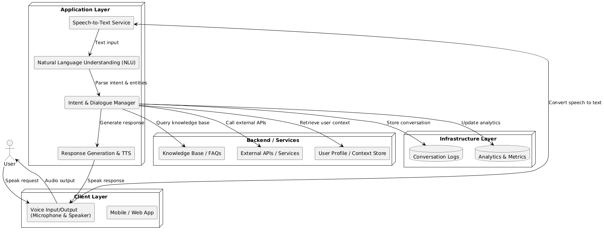
Fig-5.1
5.2 Frontend (User Interface Layer)
The frontend layer provides interaction between the user and the system.
Technologies Used:
- HTML5
- CSS3
- Bootstrap
- JavaScript
- Flask Templates
Functionalities:
- Login Page
- Registration Page
- Dashboard
- Voice Command Button
- Command History Display
- Logout Option
Responsibilities:
- Accept user input (text/voice trigger)
- Display system responses
- Show user command history
- Provide real-time feedback
- Handle error messages
The frontend communicates with the backend using HTTP requests handled by Flask routes.
5.3 Speech Recognition Layer and Text-to-Speech Layer
This layer handles input and output voice processing.
Speech Layer (Feature Extraction)
This module converts user speech into text.
Working Process:
- Capture audio from microphone.
- Convert analog audio to digital signal.
- Process audio using speech recognition engine.
- Convert audio into text.
- Send recognized text to backend processing module.
Libraries Used:
- speech_recognition
- PyAudio
Key Features:
- Real-time recognition
- Noise filtering
- Error handling for unrecognized speech
Text-to-Speech (TTS) Layer
This module converts system-generated text responses into speech.
Working Process:
- Receive text response.
- Convert text into speech waveform.
- Output voice via speakers.
Library Used:
- pyttsx3
Advantages:
- Works offline
- Adjustable voice speed and pitch
- Low resource consumption
5.4 Backend Service Layer
The backend layer is the core processing unit of the system.
Technologies Used:
- Python
- Flask
- SQLite
Responsibilities:
- Process recognized text
- Perform command matching
- Execute system operations
- Generate responses
- Manage database operations
- Handle authentication and sessions
Core Backend Modules:
- Command Processing Module
- Execution Engine
- Database Management Module
- Authentication Module
The backend ensures smooth communication between the frontend and processing layers.

5.5 Security and Privacy Considerations
Security and privacy are critical in voice-based systems.
Security Measures:
- Password hashing using secure algorithms.
- Session management with Flask.
- Protection against SQL injection.
- Input validation and sanitization.
- Secure routing and authentication.
Privacy Measures:
- Local storage of user data.
- Avoid unnecessary cloud data transmission.
- Store only essential interaction history.
- User consent before saving voice data.
These measures ensure a secure and trustworthy system.

5.6 System Design
The system design focuses on modularity and scalability.
5.6.1 System Components
The major components of the system include:
User Interface Component
2️. Speech Recognition Component
3️. Text Processing Component
4️. Command Matching Engine
5️. Execution Module
6️. Text-to-Speech Component
7️. Database Component
8️. Authentication & Session Manager
Each component performs a specific function and interacts through defined interfaces.
5.6.2 Dataflow and Process Flow
Dataflow Steps:
- User selects and uploads handwritten image.
- Image is sent to Flask backend.
- Backend validates the file format and size.
- Image preprocessing is applied.
- Preprocessed image is given to CNN.
- CNN output converted into sequence.
- RNN (BiLSTM) processes the sequence.
- CTC decoder generates predicted text.
- Output text is returned and displayed to user.
- (Optional) result stored in database for history.

5.7 Design Considerations
Several key design principles were followed:
1️. Modularity
Each module works independently for easy debugging and enhancement.
2️. Scalability
New commands and features can be added easily.
3️. Performance
Optimized for low response time.
4️. Usability
User-friendly interface with clear voice feedback.
5️. Reliability
Error handling and fallback mechanisms implemented.
6️. Maintainability
Structured codebase and documentation.

5.8 Algorithm Explanation
The Voice Based Virtual Assistant uses the following algorithms:
- Initialize microphone.
- Capture audio signal

Apply noise reduction.

convert audio to digital format.

Use speech recognition engine to convert to text.
- Return recognized text.

5.8.1. Command Processing Algorithm

Receive text input.

Convert text to lowercase.

Remove special characters.

Tokenize sentence.

Compare keywords with predefined commands.

If match found → execute mapped function.

If no match → return default response.

5.8.2. Execution Algorithm

1Identify command category.

Call corresponding function.

Perform system action (open app, fetch data, etc.).

Generate response text.

Send response to TTS module.

5.8.3. Text-to-Speech Algorithm

Initialize TTS engine.

Input response text.

Convert text into speech.

Play audio output.

UML (Unified Modeling Language)
UML (Unified Modeling Language) is a standardized modeling language used in software engineering to visualize, specify, construct, and document the artifacts of a software system. It is a graphical language used for representing the design and architecture of a system, providing a clear blueprint for developers, analysts, and
other stakeholders.
UML provides a set of diagrams and symbols that represent various aspects of a system's structure, behavior, and interactions. These diagrams can be classified into two categories: structure diagrams and behavior diagrams.

Categories of UML Diagrams:
  - Structure Diagrams: These diagrams describe the static aspects of the system, focusing on how the system's components are structured and related to each other. Common structure diagrams include:
  - Class Diagram: Represents the system’s classes, their attributes, methods, and relationships. It is often used to model the static structure of the system and is essential for object-oriented design.
  - Component Diagram: Shows the components (software modules or subsystems) and how they interact with each other.
  - Deployment Diagram: Illustrates the physical deployment of software components on hardware nodes (e.g., servers, computers, etc.).
  - Object Diagram: Represents a snapshot of the system at a particular point in time, showcasing the objects and their relationships.
  - Behavior Diagrams: These diagrams describe the dynamic behavior of the system, including how the system behaves over time or in response to various inputs. Common behavior diagrams include:
  - Use Case Diagram: Depicts the system’s functionality from the user’s perspective. It shows the actors (users or other systems) and their interactions with the system’s use cases.
  - Sequence Diagram: Describes how objects interact with each other in a specific sequence over time, showing the order of messages exchanged between objects.
  - Activity Diagram: Represents the flow of control or data within a system, focusing on the activities, decisions, and transitions between them.
  - State Diagram: Models the various states of an object or system, along with the transitions between these states based on events.
  - Collaboration Diagram: Illustrates the interactions between objects, emphasizing the organization of messages sent and received between the objects.

Importance of UML in System Design
  - Standardization: UML provides a standard way of representing complex systems, ensuring that everyone involved in the project (developers, business analysts, stakeholders) has a clear understanding of the system’s design and functionality.
  - Visual Representation: UML diagrams provide visual representations that simplify the understanding of complex systems, making it easier to identify components, relationships, and behaviors.
  - Communication Tool: UML serves as a communication tool between different stakeholders (designers, developers, business users, etc.), helping bridge the gap between technical and non-technical teams.
  - Documentation: UML is a useful documentation tool for software systems, helping in maintaining and updating the system’s design over time. It can also serve as a reference during system maintenance and troubleshooting.
  - Design and Analysis: UML is widely used during the design and analysis phases of system development. It helps developers plan and organize the system architecture before implementation.

UML Diagrams

Unified Modeling Language (UML) diagrams are a crucial tool in the system design process. They provide a visual representation of the system, its components, and their interactions. For the Blockchain-powered Organ Donation System, UML diagrams can help in visualizing how various parts of the system work together, ensuring clarity and providing a blueprint for development.

In this section, we will explore the relevant UML Diagrams for this project and their applications.

USE CASE DIAGRAM

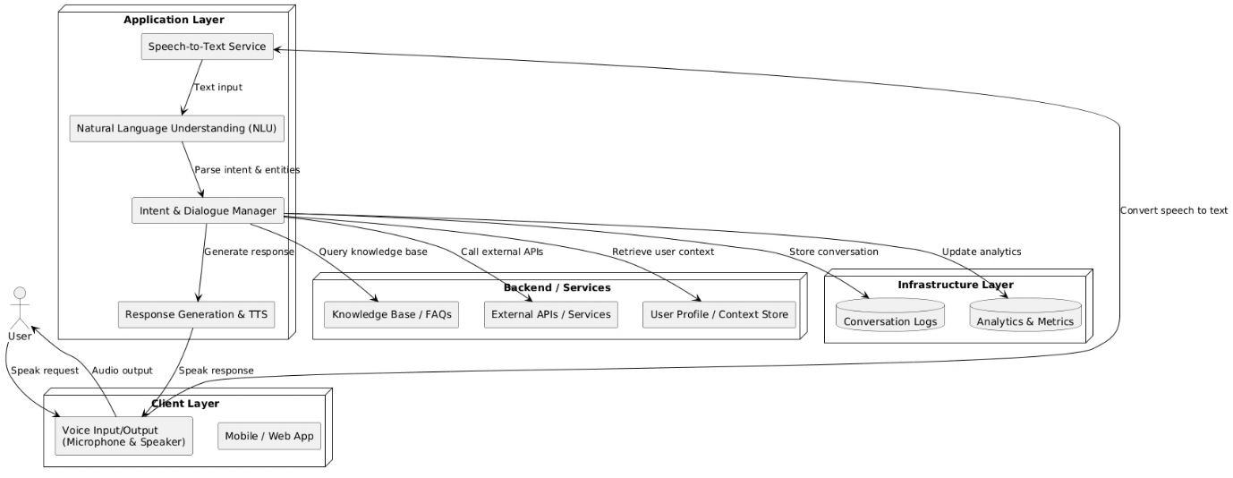

ClassDiagram
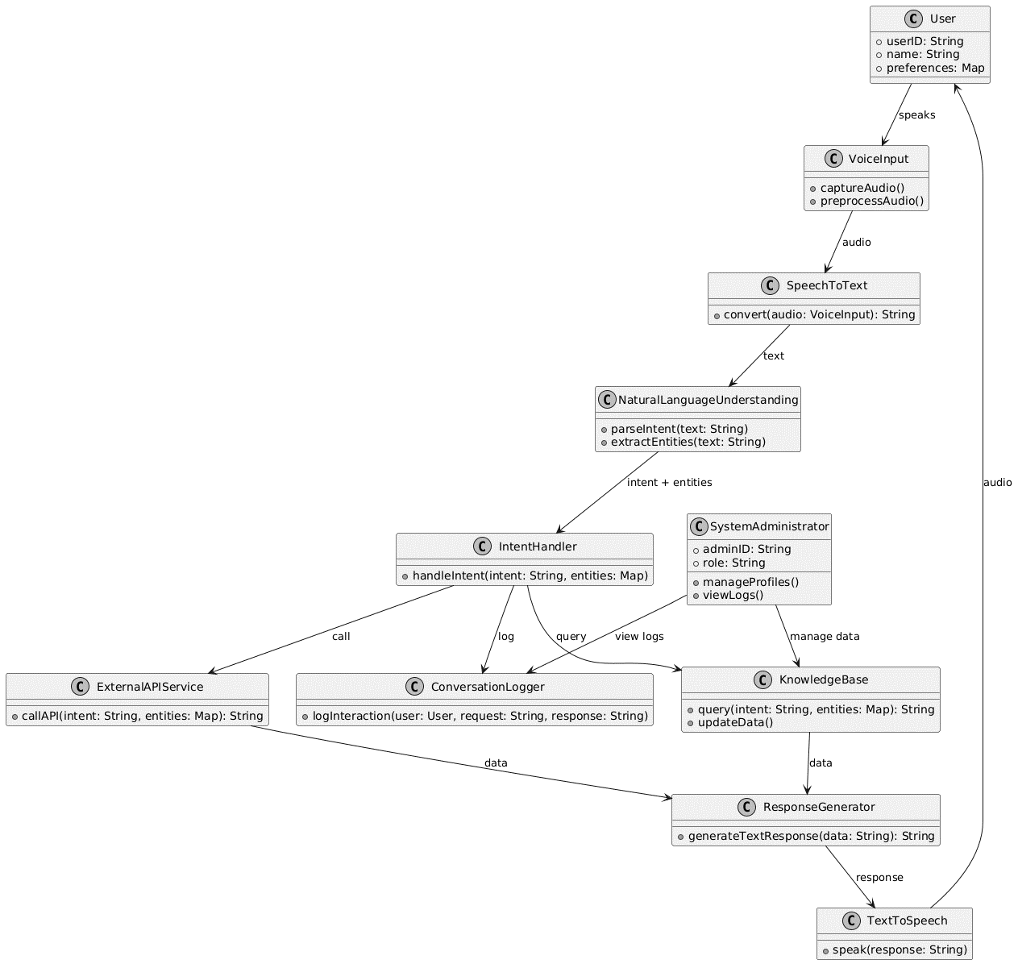
Fig 5.3 Class Diagram

Sequence Diagram

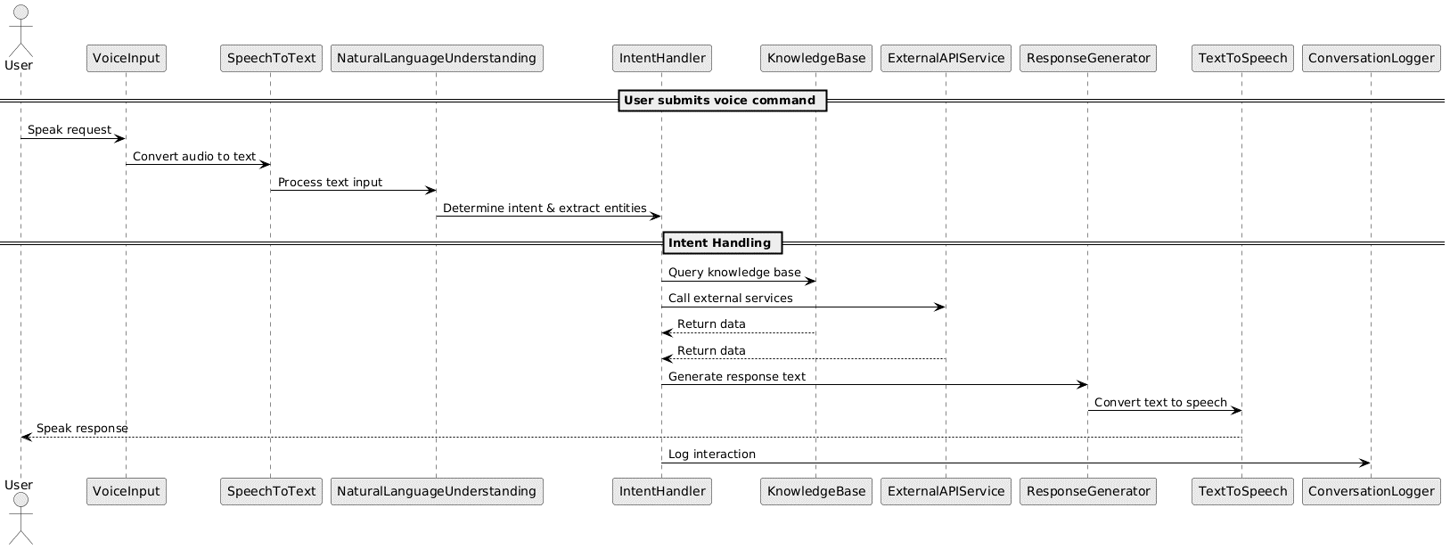
Fig 5.4 Sequence Diagram

Activity Diagram
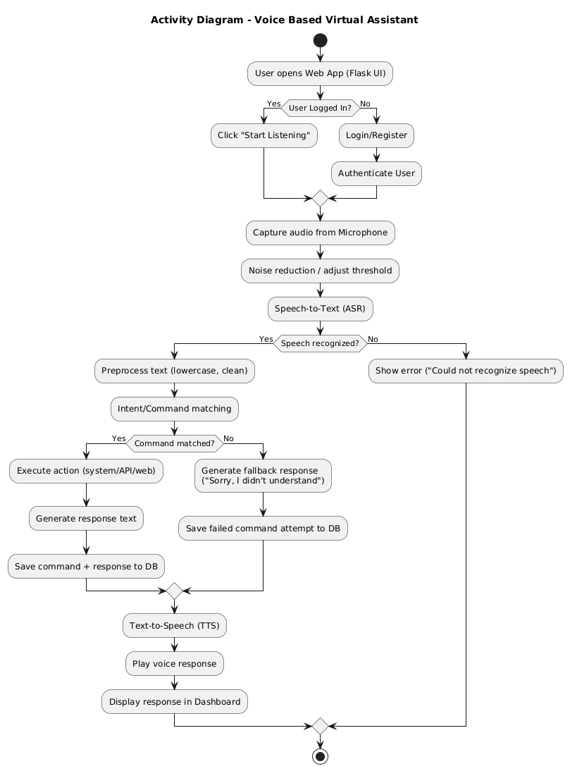
Fig 5.5 Activity Diagram

Deployment Diagram

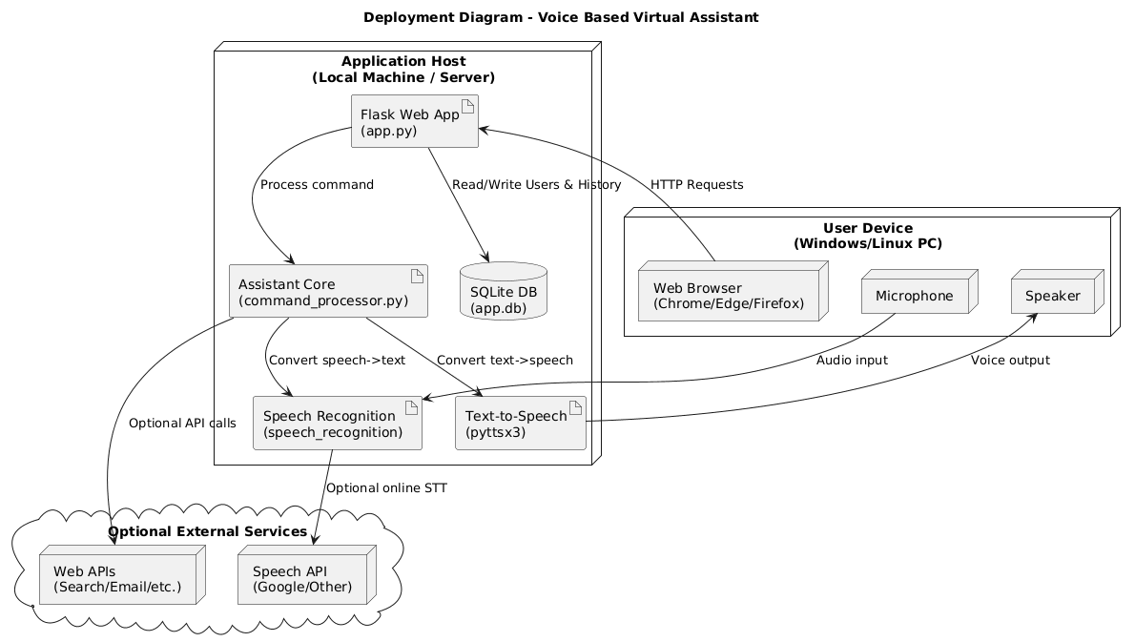
Fig 5.6 Deployment Diagram.

Data Flow Diagram
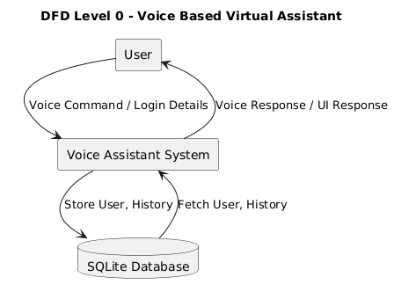

Fig 5.7 Data Flow Diagram

CHAPTER 6
IMPLEMENTATION OF VOICE BASED VIRTUAL
ASSISTANT SYSTEM
6.1 Technology Used
The development of the Voice Based Virtual Assistant system involves multiple
technologies that work together to enable speech recognition, command processing, and
web-based interaction.
1️. Programming Language
Python
Python is used as the core programming language for the entire system.
Reason for Selection:
- Easy syntax and readability
- Strong support for AI and speech libraries
- Large developer community
- Cross-platform compatibility

2️. Web Framework
Flask
Flask is used to build the web interface and backend routing.
Used For:
- Creating login and registration pages
- Handling HTTP requests
- Connecting frontend with backend logic
- Managing sessions
- Serving dashboard and history pages

3️. Speech Recognition Library
Library Used: speech_recognition
Purpose:
- Capture microphone input
- Convert speech into text
- Process real-time voice commands

4️. Text-to-Speech (TTS) Engine
Library Used: pyttsx3
Purpose:
- Convert system responses into voice output
- Provide offline speech synthesis
- Adjustable speech speed and pitch

5️. Database
Database Used: SQLite
Purpose:
- Store user credentials
- Save command history
- Manage authentication data

6️. Frontend Technologies
- HTML5
- CSS3
- Bootstrap
- JavaScript
Purpose:
- User interface design
- Dashboard layout
- Responsive web design

7️. Additional Libraries
- os – system operations
- re – text preprocessing
- sqlite3 – database connectivity
- werkzeug – password hashing
- pickle – model storage (if ML used)

6.2 Implementation
The implementation phase converts the system design into a working application. It is divided into multiple steps.

6.2.1 Environment Setup
- Install Python (3.8 or above).
- Install required libraries:
System Execution Flow
- User logs in.
- User clicks voice command button.
- Microphone captures audio.
- Speech Recognition converts speech to text.
- Backend processes command.
- Action is executed.
- Response is generated.
- Text-to-Speech provides audio output.
- Command history is stored.

CHAPTER 7
INTRODUCTION OF EXECUTION AND RESULTS
The Voice Based Virtual Assistant system was successfully implemented and tested in a local development environment using:
- Python
- Flask
- SpeechRecognition
- pyttsx3
- SQLite
The system execution involves running the Flask server and interacting with the assistant through a web browser.
7.1 Frontend

• Click the "Start Listening" button.
• Speak a command.
• View system response on dashboard and hear audio output.
Voice Interaction
When user says:
- "Open Google"
- "What is the time?"
- "Hello"
System responds correctly with:
- Text response on screen
- Voice output via speakers
Result:
Speech-to-text and text-to-speech work successfully in real time.
7.2 Backend
The backend processes voice commands and performs corresponding actions.
- Receive audio input.
- Convert speech to text.
- Process command.
- Execute action.
- Generate response.
- Store command and response.
- Return output to frontend.

Backend Functional Results
1️. Speech Recognition
- Successfully converts speech into text.
- Handles normal speaking tone.
- Displays error when speech is unclear.
Result:
Accurate speech recognition under normal noise conditions.

2️. Command Processing
- Recognizes predefined commands.
- Converts input to lowercase.
- Matches keywords.
- Returns default response for unknown commands.
Result:
Command matching works effectively.

3️. Text-to-Speech Output
- Converts response text to speech.
- Plays voice output clearly.
- Works offline.
Result:
Voice output is generated successfully.
7.3 Summary
The execution and testing phase confirms that the Voice Based Virtual Assistant system operates successfully.
Achievements:
- Secure login system implemented.
- Real-time speech recognition achieved.
- Accurate command processing.
- Text-to-Speech integration successful.
- Command history stored and retrieved correctly.
- System runs smoothly in local environment.
Overall Result:
The Voice Based Virtual Assistant demonstrates:
- Efficient voice interaction.
- Reliable backend processing.
- Secure data management.
- User-friendly web interface.
- Stable and scalable architecture.
The system meets the objectives defined in the problem statement and successfully integrates speech technologies with web deployment.

EXECUTION CODE

Frontend

Code for creating interface
Heya_launcher.py
import sys, os
sys.stdout = open(os.path.join(os.path.dirname(__file__), "log.txt"), "w")
sys.stderr = sys.stdout
from pydoc import text
import subprocess, sys, importlib
from tts_engine import TTS
import webbrowser
import threading
import speech_recognition as sr
REQUIRED_PACKAGES = [
("customtkinter", "customtkinter"),
("SpeechRecognition", "speech_recognition"),
("pyttsx3", "pyttsx3"),
("scikit-learn", "sklearn"),
("pygame", "pygame"),
("Pillow", "PIL"),
("pyaudio", "pyaudio"),
]

def install_missing():
for pkg, mod in REQUIRED_PACKAGES:
try:
importlib.import_module(mod)
except ImportError:
print(f"Installing {pkg}...")
subprocess.check_call([sys.executable, "-m", "pip", "install", pkg])

install_missing()

import tkinter as tk
import customtkinter as ctk
import threading, json, os, re, time, random, datetime
import webbrowser, platform, math, pickle
import subprocess as sp

import speech_recognition as sr
import pyttsx3, pygame
from sklearn.feature_extraction.text import TfidfVectorizer
from sklearn.linear_model import LogisticRegression
from sklearn.pipeline import Pipeline

ctk.set_appearance_mode("dark")
ctk.set_default_color_theme("blue")

OS = platform.system()
HERE = os.path.dirname(os.path.abspath(__file__))
INTENTS_FILE = os.path.join(HERE,"intents.json")
MODEL_FILE = os.path.join(HERE,"intent_model.pkl")
MUSIC_DIR = os.path.join(HERE,"music")

C = {
"bg":"#080810","surface":"#0F0F1E","card":"#16162A","border":"#22224A",
"accent":"#6C63FF","cyan":"#22D3EE","green":"#10B981","amber":"#F59E0B",
"text":"#E2E0FF","muted":"#5A5A8A","danger":"#F87171",
}

JOKES = [
"Why don't scientists trust atoms? Because they make up everything!",
"I told my computer I needed a break. Now it keeps sending me Kit-Kat ads.",
"Why do programmers prefer dark mode? Because light attracts bugs!",
"What do you call a fake noodle? An impasta!",
"I'm reading a book about anti-gravity — impossible to put down!",
"Why did the scarecrow win an award? Outstanding in his field!",
"Why don't eggs tell jokes? They'd crack each other up!",
"I used to hate facial hair, but then it grew on me.",
"What do you call cheese that isn't yours? Nacho cheese!",
"Why can't a nose be 12 inches long? Because then it would be a foot!",
]
QUOTES = [
"The only way to do great work is to love what you do. — Steve Jobs",
"In the middle of every difficulty lies opportunity. — Albert Einstein",
"It does not matter how slowly you go as long as you do not stop. — Confucius",
"Life is what happens when you are busy making other plans. — John Lennon",
"The future belongs to those who believe in the beauty of their dreams. — Eleanor Roosevelt",
"Success is not final, failure is not fatal: it is the courage to continue. — Churchill",
"Believe you can and you're halfway there. — Theodore Roosevelt",
"You miss 100% of the shots you don't take. — Wayne Gretzky",
"The secret of getting ahead is getting started. — Mark Twain",
"Whether you think you can or you think you can't, you're right. — Henry Ford",
]

COMMAND_CARDS = [
("⏰","Time", "what time is it"), ("📅","Date", "tell me the date"),
("😄","Joke", "tell me a joke"), ("💬","Quote", "tell me a quote"),
("▶️","Play Music", "play music"), ("⏹","Stop Music", "stop the music"),
("⏭","Next Song", "next song please"), ("🎵","Spotify", "open spotify"),
("🔍","Google", "open google"), ("▶️","YouTube", "open youtube"),
("📧","Gmail", "open gmail"), ("🗺️","Maps", "open maps"),
("💻","VS Code", "open visual studio code"), ("🧮","Calculator","open calculator"),
("📝","Notepad", "open notepad"), ("📅","Calendar", "open calendar"),
("📸","Screenshot", "take screenshot"), ("⚙️","Settings", "open settings"),
("📁","Explorer", "open file explorer"),("🔒","Lock", "lock screen"),
("🐍","PyCharm", "open pycharm"), ("☕","IntelliJ", "open intellij"),
("🌑","Eclipse", "open eclipse"), ("🖥️","CMD", "open cmd"),
("💬","WhatsApp", "open whatsapp"), ("📨","Telegram", "open telegram"),
("💼","LinkedIn", "open linkedin"), ("☁️","Drive", "open google drive"),
("🔢","Math", "calculate 5 plus 3"),("🌐","Translate", "translate this word"),
("📰","News", "get latest news"), ("✈️","Flight", "book a flight"),
]

# ── Model ─────────────────────────────────────────────────────
def load_or_train():
needs = (not os.path.exists(MODEL_FILE) or
os.path.getmtime(INTENTS_FILE) > os.path.getmtime(MODEL_FILE))
if needs:
print(" Training intent model...")
with open(INTENTS_FILE, encoding="utf-8") as f:
raw = json.load(f)
X, y = [], []
if isinstance(raw, list):
for group in raw:
for item in group:
if "text" in item and "label" in item:
X.append(item["text"].lower()); y.append(item["label"])
else:
for intent in raw.get("intents",[]):
for p in intent.get("patterns",[]):
X.append(p.lower()); y.append(intent["tag"])
pipe = Pipeline([
("tfidf", TfidfVectorizer(ngram_range=(1,3), analyzer="char_wb")),
("clf", LogisticRegression(max_iter=2000, C=10.0)),
])
pipe.fit(X, y)
with open(MODEL_FILE,"wb") as f: pickle.dump(pipe, f)
print(f" Trained on {len(X)} samples → {len(set(y))} intents")
else:
with open(MODEL_FILE,"rb") as f: pipe = pickle.load(f)
print(f" Model loaded.")
return pipe

def predict(model, text):
tag = model.predict([text.lower()])[0]
conf = float(max(model.predict_proba([text.lower()])[0]))
return tag, conf

# ── TTS ───────────────────────────────────────────────────────
class TTS:
def __init__(self):
import pyttsx3
self.engine = pyttsx3.init()
self.engine.setProperty("rate", 150) # smoother pace
self.engine.setProperty("volume", 1)

# Prefer female voice, fallback to male
voices = self.engine.getProperty("voices")
female_voice = None
male_voice = None

for v in voices:
name = v.name.lower()
if "female" in name or "zira" in v.id.lower() or "hazel" in v.id.lower():
female_voice = v.id
break
if "male" in name or "david" in v.id.lower() or "mark" in v.id.lower():
male_voice = v.id

if female_voice:
self.engine.setProperty("voice", female_voice)
elif male_voice:
self.engine.setProperty("voice", male_voice)
else:
# If neither is found, just use the first available voice
self.engine.setProperty("voice", voices[0].id)

def speak(self, text, done_cb=None):
self.engine.say(text)
self.engine.runAndWait()
if done_cb:
done_cb()

# ── Recogniser ────────────────────────────────────────────────
import speech_recognition as sr

class Recogniser:

def __init__(self):
self.recognizer = sr.Recognizer()

def listen(self):

with sr.Microphone() as source:

print("Listening...")

self.recognizer.adjust_for_ambient_noise(source)

audio = self.recognizer.listen(source)

try:
text = self.recognizer.recognize_google(audio)
return text.lower()

except sr.UnknownValueError:
return ""

except sr.RequestError:
return ""

# ── Music Player ──────────────────────────────────────────────
class MusicPlayer:
def __init__(self, music_dir):
pygame.mixer.init()
self._dir = music_dir
self._tracks = []
self._index = 0
self._refresh()

def _refresh(self):
if os.path.isdir(self._dir):
self._tracks = sorted([
os.path.join(self._dir, f) for f in os.listdir(self._dir)
if f.lower().endswith(".mp3")
])

def play(self):
self._refresh()
if not self._tracks:
return "No MP3 files found. Add .mp3 files to the music folder next to this script."
try:
if pygame.mixer.music.get_busy():
pygame.mixer.music.unpause()
return "Resuming music."
pygame.mixer.music.stop()
pygame.mixer.music.load(self._tracks[self._index])
pygame.mixer.music.play()
name = os.path.splitext(os.path.basename(self._tracks[self._index]))[0]
return f"Now playing: {name}."
except Exception as e:
return f"Could not play music. {e}"

def stop(self):
pygame.mixer.music.stop()
return "Music stopped."

def next_track(self):
self._refresh()
if not self._tracks:
return "No tracks found in the music folder."
self._index = (self._index + 1) % len(self._tracks)
try:
pygame.mixer.music.stop()
pygame.mixer.music.load(self._tracks[self._index])
pygame.mixer.music.play()
name = os.path.splitext(os.path.basename(self._tracks[self._index]))[0]
return f"Playing next: {name}."
except Exception as e:
return f"Could not skip track. {e}"

def get_track_list(self):
self._refresh()
return [os.path.splitext(os.path.basename(t))[0] for t in self._tracks]

def is_playing(self):
return pygame.mixer.music.get_busy()

# ── Helpers ───────────────────────────────────────────────────
def _open_url(url, label):
webbrowser.open(url)
return f"Opening {label} in your browser."

def _open_app(win_cmd, mac_app, linux_cmd, label):
try:
if OS == "Windows": sp.Popen(win_cmd, shell=True)
elif OS == "Darwin": sp.Popen(["open","-a",mac_app])
else: sp.Popen(linux_cmd, shell=True)
return f"Opening {label}."
except Exception as e:
return f"Could not open {label}. {e}"

def _kill(name):
try:
if OS == "Windows": sp.run(["taskkill","/f","/im",f"{name}.exe"], capture_output=True)
else: sp.run(["pkill","-f",name], capture_output=True)
return f"Closing {name}."
except Exception:
return f"Could not close {name}."

# ── Actions ───────────────────────────────────────────────────
class Actions:
def __init__(self, music, ask_fn):
self._music = music
self._ask = ask_fn

def dispatch(self, tag, text):
fn = getattr(self, f"_do_{tag}", None)
if fn: return fn(text)
return f"Handling {tag.replace('_',' ')}."

# time/date
def _do_greet(self, t):
h = datetime.datetime.now().hour
p = "Good morning" if h<12 else "Good afternoon" if h<17 else "Good evening"
return f"{p}! I am Heya, your personal voice assistant. How can I help?"
def _do_tell_time(self, t):
return "The current time is " + datetime.datetime.now().strftime("%I:%M %p") + "."
def _do_tell_date(self, t):
return "Today is " + datetime.datetime.now().strftime("%A, %B %d, %Y") + "."

# music
def _do_play_music(self, t): return self._music.play()
def _do_stop_music(self, t): return self._music.stop()
def _do_next_song(self, t): return self._music.next_track()
def _do_close_music_player(self, t): return self._music.stop()
def _do_open_music_player(self, t): return self._music.play()

# fun
def _do_tell_joke(self, t): return random.choice(JOKES)
def _do_tell_quote(self, t): return random.choice(QUOTES)

# web
def _do_open_youtube(self, t): return _open_url("https://youtube.com", "YouTube")
def _do_open_google(self, t): return _open_url("https://google.com", "Google")
def _do_open_gmail(self, t): return _open_url("https://mail.google.com", "Gmail")
def _do_open_maps(self, t): return _open_url("https://maps.google.com", "Google Maps")
def _do_open_spotify(self, t): return _open_url("https://open.spotify.com", "Spotify")
def _do_open_netflix(self, t): return _open_url("https://netflix.com", "Netflix")
def _do_open_facebook(self, t): return _open_url("https://facebook.com", "Facebook")
def _do_open_twitter(self, t): return _open_url("https://twitter.com", "Twitter")
def _do_open_linkedin(self, t): return _open_url("https://linkedin.com", "LinkedIn")
def _do_open_whatsapp(self, t): return _open_url("https://web.whatsapp.com", "WhatsApp")
def _do_open_telegram(self, t): return _open_url("https://web.telegram.org", "Telegram")
def _do_open_google_drive(self,t): return _open_url("https://drive.google.com", "Google Drive")
def _do_open_icloud(self, t): return _open_url("https://icloud.com", "iCloud")
def _do_open_onedrive(self, t): return _open_url("https://onedrive.live.com", "OneDrive")
def _do_open_dropbox(self, t): return _open_url("https://dropbox.com", "Dropbox")
def _do_open_hotstar(self, t): return _open_url("https://hotstar.com", "Hotstar")
def _do_open_prime_video(self, t): return _open_url("https://primevideo.com", "Prime Video")
def _do_open_discord(self, t): return _open_url("https://discord.com/app", "Discord")
def _do_open_slack(self, t): return _open_url("https://app.slack.com", "Slack")
def _do_open_zoom(self, t): return _open_url("https://zoom.us", "Zoom")
def _do_open_teams(self, t): return _open_url("https://teams.microsoft.com", "Microsoft Teams")
def _do_open_skype(self, t): return _open_url("https://web.skype.com", "Skype")
def _do_open_evernote(self, t): return _open_url("https://evernote.com/client/web","Evernote")
def _do_open_steam(self, t): return _open_url("https://store.steampowered.com","Steam")

# search
def _do_search_google(self, text):
noise = ["search on google","google something for me","search for",
"search google for","look up","find information about","google","search"]
q = text.lower()
for n in sorted(noise, key=len, reverse=True): q = q.replace(n,"")
q = q.strip()
if not q: q = self._ask("What should I search for?") or ""
if q:
webbrowser.open(f"https://google.com/search?q={q}")
return f"Searching Google for {q}."
return "No search query provided."

# desktop apps
def _do_open_calculator(self, t): return _open_app("calc","Calculator","gnome-calculator","Calculator")
def _do_open_notepad(self, t): return _open_app("notepad","TextEdit","gedit","Notepad")
def _do_open_calendar(self, t):
if OS == "Windows": webbrowser.open("https://calendar.google.com")
elif OS == "Darwin": sp.Popen(["open","-a","Calendar"])
else: sp.Popen("gnome-calendar", shell=True)
return "Opening Calendar."
def _do_open_chrome(self, t): return _open_app("start chrome","Google Chrome","google-chrome","Google Chrome")
def _do_open_edge(self, t): return _open_app("start msedge","Microsoft Edge","microsoft-edge","Microsoft Edge")
def _do_open_vscode(self, t): return _open_app("code","Visual Studio Code","code","VS Code")
def _do_open_pycharm(self, t): return _open_app("pycharm","PyCharm","pycharm.sh","PyCharm")
def _do_open_intellij(self, t): return _open_app("idea","IntelliJ IDEA","idea.sh","IntelliJ IDEA")
def _do_open_eclipse(self, t): return _open_app("eclipse","Eclipse","eclipse","Eclipse")
def _do_open_sublime(self, t): return _open_app("subl","Sublime Text","subl","Sublime Text")
def _do_open_android_studio(self,t): return _open_app("studio64","Android Studio","android-studio","Android Studio")
def _do_open_netbeans(self, t): return _open_app("netbeans","NetBeans","netbeans","NetBeans")
def _do_open_word(self, t): return _open_app("start winword","Microsoft Word","libreoffice --writer","Microsoft Word")
def _do_open_excel(self, t): return _open_app("start excel","Microsoft Excel","libreoffice --calc","Microsoft Excel")
def _do_open_powerpoint(self, t): return _open_app("start powerpnt","Microsoft PowerPoint","libreoffice --impress","PowerPoint")
def _do_open_outlook(self, t): return _open_app("start outlook","Microsoft Outlook","thunderbird","Outlook")
def _do_open_photoshop(self, t): return _open_app("photoshop","Adobe Photoshop","gimp","Photoshop")
def _do_open_adobe_reader(self, t): return _open_app("AcroRd32","Adobe Acrobat Reader","evince","Adobe Reader")
def _do_open_paint(self, t): return _open_app("mspaint","Preview","pinta","Paint")
def _do_open_sticky_notes(self, t): return _open_app("stikynot","Stickies","gnote","Sticky Notes")
def _do_open_task_manager(self, t): return _open_app("taskmgr","Activity Monitor","gnome-system-monitor","Task Manager")
def _do_open_cmd(self, t): return _open_app("start cmd","Terminal","x-terminal-emulator","Command Prompt")
def _do_open_settings(self, t): return _open_app("start ms-settings:","System Preferences","gnome-control-center","Settings")
def _do_open_control_panel(self, t): return _open_app("control","System Preferences","gnome-control-center","Control Panel")
def _do_open_file_explorer(self, t):
if OS=="Windows": sp.Popen("explorer")
elif OS=="Darwin": sp.Popen(["open", os.path.expanduser("~")])
else: sp.Popen("nautilus ~", shell=True)
return "Opening File Explorer."
def _do_open_snipping_tool(self, t): return _open_app("snippingtool","Screenshot","gnome-screenshot","Snipping Tool")
def _do_open_device_manager(self,t): return _open_app("devmgmt.msc","System Information","hardinfo","Device Manager")
def _do_open_registry_editor(self,t):return _open_app("regedit","Terminal","xterm","Registry Editor")
def _do_open_gitbash(self, t): return _open_app("\"C:\\Program Files\\Git\\git-bash.exe\"","Terminal","x-terminal-emulator","Git Bash")
def _do_open_virtualbox(self, t): return _open_app("virtualbox","VirtualBox","virtualbox","VirtualBox")
def _do_open_vmware(self, t): return _open_app("vmware","VMware Fusion","vmware","VMware")
def _do_open_antivirus(self, t): return _open_app("start windowsdefender:","System Preferences","clamtk","Antivirus")
def _do_open_defender(self, t): return _open_app("start windowsdefender:","Security","clamtk","Windows Defender")

# close commands
def _do_close_notepad(self, t): return _kill("notepad")
def _do_close_calculator(self, t): return _kill("calc")
def _do_close_chrome(self, t): return _kill("chrome")
def _do_close_edge(self, t): return _kill("msedge")
def _do_close_vscode(self, t): return _kill("code")
def _do_close_youtube(self, t): return "Closing YouTube tab in your browser."
def _do_close_google(self, t): return "Closing Google tab in your browser."
def _do_close_gmail(self, t): return "Closing Gmail tab in your browser."
def _do_close_spotify(self, t): return _kill("spotify")
def _do_close_word(self, t): return _kill("winword")
def _do_close_excel(self, t): return _kill("excel")
def _do_close_powerpoint(self, t): return _kill("powerpnt")
def _do_close_outlook(self, t): return _kill("outlook")
def _do_close_pycharm(self, t): return _kill("pycharm")
def _do_close_intellij(self, t): return _kill("idea")
def _do_close_eclipse(self, t): return _kill("eclipse")
def _do_close_sublime(self, t): return _kill("subl")
def _do_close_android_studio(self,t): return _kill("studio")
def _do_close_netbeans(self, t): return _kill("netbeans")
def _do_close_discord(self, t): return _kill("discord")
def _do_close_slack(self, t): return _kill("slack")
def _do_close_zoom(self, t): return _kill("zoom")
def _do_close_teams(self, t): return _kill("teams")
def _do_close_skype(self, t): return _kill("skype")
def _do_close_telegram(self, t): return _kill("telegram")
def _do_close_whatsapp(self, t): return _kill("whatsapp")
def _do_close_facebook(self, t): return "Closing Facebook tab in your browser."
def _do_close_twitter(self, t): return "Closing Twitter tab in your browser."
def _do_close_linkedin(self, t): return "Closing LinkedIn tab in your browser."
def _do_close_netflix(self, t): return _kill("netflix")
def _do_close_hotstar(self, t): return "Closing Hotstar tab in your browser."
def _do_close_prime_video(self, t): return "Closing Prime Video tab in your browser."
def _do_close_google_drive(self, t): return "Closing Google Drive tab in your browser."
def _do_close_icloud(self, t): return "Closing iCloud tab in your browser."
def _do_close_onedrive(self, t): return _kill("onedrive")
def _do_close_dropbox(self, t): return _kill("dropbox")
def _do_close_steam(self, t): return _kill("steam")
def _do_close_evernote(self, t): return _kill("evernote")
def _do_close_photoshop(self, t): return _kill("photoshop")
def _do_close_adobe_reader(self, t): return _kill("acrobat")
def _do_close_paint(self, t): return _kill("mspaint")
def _do_close_sticky_notes(self, t): return _kill("stikynot")
def _do_close_task_manager(self, t): return _kill("taskmgr")
def _do_close_cmd(self, t): return _kill("cmd")
def _do_close_settings(self, t): return _kill("SystemSettings")
def _do_close_control_panel(self, t): return _kill("control")
def _do_close_file_explorer(self, t): return _kill("explorer")
def _do_close_snipping_tool(self, t): return _kill("snippingtool")
def _do_close_device_manager(self,t): return _kill("mmc")
def _do_close_registry_editor(self,t):return _kill("regedit")
def _do_close_gitbash(self, t): return _kill("git-bash")
def _do_close_virtualbox(self, t): return _kill("virtualbox")
def _do_close_vmware(self, t): return _kill("vmware")
def _do_close_antivirus(self, t): return "Closing antivirus application."
def _do_close_defender(self, t): return "Closing Windows Defender."

# system
def _do_take_screenshot(self, t):
try:
import pyautogui
ts = datetime.datetime.now().strftime("%Y%m%d_%H%M%S")
path = os.path.join(os.path.expanduser("~"), f"heya_screenshot_{ts}.png")
pyautogui.screenshot(path)
return f"Screenshot saved as heya_screenshot_{ts}.png."
except ImportError:
if OS=="Windows": sp.Popen("snippingtool", shell=True)
return "Opening screenshot tool."
def _do_record_screen(self, t):
return "Screen recording needs OBS Studio. Download it from obsproject.com."
def _do_lock_screen(self, t):
if OS=="Windows": sp.Popen("rundll32.exe user32.dll,LockWorkStation", shell=True)
elif OS=="Darwin": sp.Popen(["pmset","displaysleepnow"])
else: sp.Popen("gnome-screensaver-command -l", shell=True)
return "Locking your screen."
def _do_shutdown_computer(self, t):
return "For safety, please shut down manually from the Start menu."
def _do_restart_computer(self, t):
return "For safety, please restart manually from the Start menu."
def _do_log_off(self, t):
return "For safety, please log off manually."
def _do_open_clipboard(self, t):
if OS=="Windows": sp.Popen("ms-settings:clipboard", shell=True)
return "Opening clipboard history."
def _do_clear_clipboard(self, t):
try:
import pyperclip; pyperclip.copy("")
except ImportError: pass
return "Clipboard cleared."
def _do_open_downloads(self, t):
path = os.path.join(os.path.expanduser("~"), "Downloads")
if OS=="Windows": sp.Popen(f'explorer "{path}"', shell=True)
elif OS=="Darwin": sp.Popen(["open", path])
else: sp.Popen(f'xdg-open "{path}"', shell=True)
return "Opening Downloads folder."
def _do_open_desktop(self, t):
path = os.path.join(os.path.expanduser("~"), "Desktop")
if OS=="Windows": sp.Popen(f'explorer "{path}"', shell=True)
elif OS=="Darwin": sp.Popen(["open", path])
else: sp.Popen(f'xdg-open "{path}"', shell=True)
return "Opening Desktop folder."

# utilities
def _do_calculate_math(self, text):
expr = (text.lower()
.replace("calculate","").replace("compute","").replace("solve","")
.replace("evaluate","").replace("what is","").replace("find","")
.replace("plus","+").replace("minus","-").replace("times","*")
.replace("multiplied by","*").replace("divided by","/")
.replace("to the power of","**").strip())
try:
safe = re.sub(r"[^0-9+\-*/().\s]","", expr)
result = eval(safe) # noqa
return f"The answer is {result}."
except Exception:
return "I could not calculate that. Try saying calculate 5 plus 3."
def _do_translate_word(self, t):
webbrowser.open("https://translate.google.com")
return "Opening Google Translate for you."
def _do_weather_info(self, t):
webbrowser.open("https://weather.com")
return "Opening Weather for you."
def _do_get_news(self, t):
webbrowser.open("https://news.google.com")
return "Opening Google News for you."
def _do_book_flight(self, t):
webbrowser.open("https://www.google.com/travel/flights")
return "Opening Google Flights to help you book a flight."
def _do_set_alarm(self, text):
m = re.search(r"(\d{1,2})[:\.]?(\d{0,2})\s*(am|pm)?", text, re.I)
if m:
hr = int(m.group(1)); mn = int(m.group(2) or 0)
per = (m.group(3) or "").lower()
if per=="pm" and hr!=12: hr+=12
if per=="am" and hr==12: hr=0
webbrowser.open("https://calendar.google.com")
return f"Alarm noted for {hr:02d}:{mn:02d}. Opening Google Calendar to confirm."
webbrowser.open("https://calendar.google.com")
return "Opening Google Calendar for you to set an alarm."
def _do_set_timer(self, text):
m = re.search(r"(\d+)\s*(second|minute|hour|sec|min|hr)", text, re.I)
if m:
val = int(m.group(1)); unit = m.group(2).lower()
webbrowser.open(f"https://www.google.com/search?q={val}+{unit}+timer")
return f"Starting a {val} {unit} timer via Google."
webbrowser.open("https://www.google.com/search?q=timer")
return "Opening a timer for you."
def _do_create_note(self, t):
webbrowser.open("https://keep.google.com")
return "Opening Google Keep to create a note."
def _do_create_reminder(self, t):
webbrowser.open("https://calendar.google.com")
return "Opening Google Calendar to set a reminder."
def _do_send_email(self, t):
webbrowser.open("https://mail.google.com/mail/u/0/#compose")
return "Opening Gmail compose window."

# ── Orb ───────────────────────────────────────────────────────
class OrbCanvas(tk.Canvas):
_SC = {"idle":"#6C63FF","listening":"#22D3EE","processing":"#F59E0B","speaking":"#10B981"}

def __init__(self, parent, size=174):
super().__init__(parent, width=size, height=size, bg=C["bg"], highlightthickness=0)
self.cx=size//2; self.cy=size//2; self.R=size//2-22
self.state="idle"; self._ang=0.0; self._ph=0.0
self._tick()

def set_state(self, s): self.state=s
def _tick(self):
sp={"idle":0.6,"listening":3.5,"processing":5.0,"speaking":2.2}
self._ang=(self._ang+sp.get(self.state,1.0))%360; self._ph+=0.10
self._draw(); self.after(30, self._tick)
def _draw(self):
self.delete("all")
cx,cy,R=self.cx,self.cy,self.R; col=self._SC.get(self.state,"#6C63FF")
for off,a in [(28,.04),(18,.09),(9,.18)]:
rr=R+off; self.create_oval(cx-rr,cy-rr,cx+rr,cy+rr,outline=self._dim(col,a),width=1,fill="")
a1=math.radians(self._ang)
for a,sz in [(a1,5),(a1+math.pi,3)]:
dx=cx+(R+15)*math.cos(a); dy=cy+(R+15)*math.sin(a)
self.create_oval(dx-sz,dy-sz,dx+sz,dy+sz,fill=col,outline="")
self.create_oval(cx-R,cy-R,cx+R,cy+R,fill=col,outline="")
self.create_oval(cx-R+10,cy-R+10,cx-R+32,cy-R+32,fill="#FFFFFF",outline="",stipple="gray25")
if self.state in ("listening","speaking","processing"): self._waves(cx,cy)
else: self._mic(cx,cy)
def _waves(self,cx,cy):
n,bw,gap=7,4,5; total=n*bw+(n-1)*gap; x0=cx-total//2
for i in range(n):
h=max(26*abs(math.sin(self._ph+i*0.8)),5); x=x0+i*(bw+gap)
self.create_rectangle(x,cy+h/2,x+bw,cy-h/2,fill="#FFFFFF",outline="")
def _mic(self,cx,cy):
mw,mh=10,15
self.create_rectangle(cx-mw//2,cy-mh//2,cx+mw//2,cy+mh//2,fill="#FFFFFF",outline="")
self.create_arc(cx-mw,cy-2,cx+mw,cy+mh,start=0,extent=-180,style="arc",outline="#FFFFFF",width=2)
self.create_line(cx,cy+mh//2+2,cx,cy+mh//2+7,fill="#FFFFFF",width=2)
self.create_line(cx-5,cy+mh//2+7,cx+5,cy+mh//2+7,fill="#FFFFFF",width=2)

@staticmethod
def _dim(h,a):
r=int(int(h[1:3],16)*a); g=int(int(h[3:5],16)*a); b=int(int(h[5:7],16)*a)
return f"#{r:02x}{g:02x}{b:02x}"

# ── Main Window ───────────────────────────────────────────────
class heyaApp(ctk.CTk):
def __init__(self, model):
super().__init__()
self.title("Heya — Voice Assistant")
self.geometry("460x860"); self.minsize(420,720)
self.configure(fg_color=C["bg"])
self._model=model; self._tts=TTS(); self._rec=Recogniser()
self._music=MusicPlayer(MUSIC_DIR)
self._acts=Actions(self._music, self._ask_voice)
self._state="idle"
self._build_ui()
self.protocol("WM_DELETE_WINDOW", self._quit)
self.bind("<space>", lambda e: self._toggle_listen())
self.bind("<Escape>", lambda e: self._go_idle())
self.after(700, lambda: self._respond(
" Hello! I am Heya, your personal voice assistant."
"You May Speak Now...."))
self._tts = TTS()
self.after(2000, self._always_listen)
self.start_continuous_listening()
def start_continuous_listening(self):
def loop():

while True:

if not self._speaking:

try:
text = self._rec.listen()

if text and text.strip() != "":
print("You:", text)
self._process_worker(text)

except Exception as e:
print("Listening error:", e)

threading.Thread(target=loop, daemon=True).start()
def _build_ui(self):
self.grid_columnconfigure(0,weight=1); self.grid_rowconfigure(6,weight=1)
self._build_topbar(); self._build_orb(); self._build_status()
self._build_chat(); self._build_controls()
self._build_music_bar(); self._build_commands()

def _build_topbar(self):
bar=ctk.CTkFrame(self,fg_color=C["surface"],corner_radius=0,height=48)
bar.grid(row=0,column=0,sticky="ew"); bar.grid_columnconfigure(1,weight=1)
ctk.CTkLabel(bar,text="🎙",font=("Segoe UI Emoji",20),text_color=C["accent"]).grid(row=0,column=0,padx=(14,6),pady=10)
ctk.CTkLabel(bar,text="HEYA",font=("Segoe UI",17,"bold"),text_color=C["text"]).grid(row=0,column=1,sticky="w")
self._dot=ctk.CTkLabel(bar,text="●",font=("Segoe UI",13),text_color=C["green"])
self._dot.grid(row=0,column=2,padx=4)
self._bar_lbl=ctk.CTkLabel(bar,text="Ready",font=("Segoe UI",10),text_color=C["muted"])
self._bar_lbl.grid(row=0,column=3,padx=(0,14))
def _always_listen(self):
def loop():
while True:
try:
text = self._rec.listen()
if text:
print("You:", text)
self._process_worker(text)
except Exception as e:
print("Listening error:", e)
threading.Thread(target=loop, daemon=True).start()
def _build_orb(self):
frm=ctk.CTkFrame(self,fg_color=C["bg"]); frm.grid(row=1,column=0,pady=(14,0))
self._orb=OrbCanvas(frm,size=174); self._orb.pack()
self._orb.bind("<Button-1>",lambda e: self._toggle_listen())
self._orb.configure(cursor="hand2")
def _build_status(self):
self._status_var=tk.StringVar(value="Press Space or tap the orb")
self._status_lbl=ctk.CTkLabel(self,textvariable=self._status_var,font=("Segoe UI",11),text_color=C["muted"])
self._status_lbl.grid(row=2,column=0,pady=(4,0))
def _build_chat(self):
outer=ctk.CTkFrame(self,fg_color=C["surface"],corner_radius=12)
outer.grid(row=3,column=0,sticky="ew",padx=16,pady=(10,0)); outer.grid_columnconfigure(0,weight=1)
ctk.CTkLabel(outer,text="CONVERSATION",font=("Segoe UI",8,"bold"),text_color=C["muted"]).grid(row=0,column=0,sticky="w",padx=12,pady=(8,2))
self._chat=ctk.CTkTextbox(outer,height=95,font=("Segoe UI",11),fg_color=C["card"],text_color=C["text"],corner_radius=8,wrap="word",state="disabled")
self._chat.grid(row=1,column=0,sticky="ew",padx=8,pady=(0,8))
def _build_controls(self):
row=ctk.CTkFrame(self,fg_color="transparent"); row.grid(row=4,column=0,sticky="ew",padx=16,pady=8)
row.grid_columnconfigure((0,1,2),weight=1)
self._listen_btn=ctk.CTkButton(row,text="🎤 Listen",font=("Segoe UI",11),fg_color=C["accent"],hover_color="#5550CC",corner_radius=50,height=38,command=self._toggle_listen)
self._listen_btn.grid(row=0,column=0,padx=(0,4),sticky="ew")
ctk.CTkButton(row,text="⏹ Stop",font=("Segoe UI",11),fg_color=C["card"],hover_color=C["border"],corner_radius=50,height=38,command=self._go_idle).grid(row=0,column=1,padx=4,sticky="ew")
ctk.CTkButton(row,text="✕ Quit",font=("Segoe UI",11),fg_color=C["card"],hover_color="#7F1D1D",text_color=C["danger"],corner_radius=50,height=38,command=self._quit).grid(row=0,column=2,padx=(4,0),sticky="ew")
def _build_music_bar(self):
bar=ctk.CTkFrame(self,fg_color=C["surface"],corner_radius=10)
bar.grid(row=5,column=0,sticky="ew",padx=16,pady=(0,4)); bar.grid_columnconfigure(1,weight=1)
ctk.CTkLabel(bar,text="🎵",font=("Segoe UI Emoji",14)).grid(row=0,column=0,padx=(12,6),pady=8)
self._now_playing=tk.StringVar(value="No track playing")
ctk.CTkLabel(bar,textvariable=self._now_playing,font=("Segoe UI",10),text_color=C["muted"]).grid(row=0,column=1,sticky="w")
for col,(txt,cmd) in enumerate([
("▶",lambda: self._run_cmd("play music")),
("⏹",lambda: self._run_cmd("stop the music")),
("⏭",lambda: self._run_cmd("next song please")),
],start=2):
ctk.CTkButton(bar,text=txt,width=32,height=28,font=("Segoe UI",12),fg_color=C["card"],hover_color=C["border"],corner_radius=6,command=cmd).grid(row=0,column=col,padx=3,pady=6)
ctk.CTkButton(bar,text="≡",width=32,height=28,font=("Segoe UI",12),fg_color=C["card"],hover_color=C["border"],corner_radius=6,command=self._show_tracks).grid(row=0,column=5,padx=(3,12),pady=6)

def _build_commands(self):
ctk.CTkLabel(self,text="COMMANDS — click any card to run",font=("Segoe UI",8,"bold"),text_color=C["muted"]).grid(row=5,column=0,sticky="w",padx=20,pady=(6,2))
scroll=ctk.CTkScrollableFrame(self,fg_color=C["surface"],corner_radius=12,height=210)
scroll.grid(row=6,column=0,sticky="nsew",padx=16,pady=(0,14)); self.grid_rowconfigure(6,weight=1)
cols=4
for c in range(cols): scroll.grid_columnconfigure(c,weight=1)
for idx,(icon,label,phrase) in enumerate(COMMAND_CARDS):
r,c=divmod(idx,cols); self._make_card(scroll,icon,label,phrase,r,c)

def _make_card(self,parent,icon,label,phrase,r,c):
card=ctk.CTkFrame(parent,fg_color=C["card"],corner_radius=10,cursor="hand2")
card.grid(row=r,column=c,padx=3,pady=3,sticky="nsew")
ctk.CTkLabel(card,text=icon,font=("Segoe UI Emoji",17)).pack(pady=(9,1))
ctk.CTkLabel(card,text=label,font=("Segoe UI",9),text_color=C["text"],wraplength=90).pack(pady=(0,8))
def _click(e=None,p=phrase):
if self._state=="idle": self._run_cmd(p)
card.bind("<Button-1>",_click)
for ch in card.winfo_children(): ch.bind("<Button-1>",_click)
def _enter(e,w=card): w.configure(fg_color=C["border"])
def _leave(e,w=card): w.configure(fg_color=C["card"])
card.bind("<Enter>",_enter); card.bind("<Leave>",_leave)
def _set_state(self,state,status,bar):
self._state=state; self._orb.set_state(state)
self._status_var.set(status); self._bar_lbl.configure(text=bar)
dc={"idle":C["green"],"listening":C["cyan"],"processing":C["amber"],"speaking":C["green"]}.get(state,C["muted"])
self._dot.configure(text_color=dc)
sc={"idle":C["muted"],"listening":C["cyan"],"processing":C["amber"],"speaking":C["green"]}.get(state,C["muted"])
self._status_lbl.configure(text_color=sc)
def _go_idle(self):
self._set_state("idle","Press Space or tap the orb","Ready")
self._listen_btn.configure(text="🎤 Listen",fg_color=C["accent"]
def _log(self,role,text):
self._chat.configure(state="normal")
prefix="👤 You: " if role=="user" else "🔊 heya: "
self._chat.insert("end",prefix+text+"\n\n"); self._chat.see("end")
self._chat.configure(state="disabled")
def _toggle_listen(self):
if self._state=="listening": self._go_idle()
else: self._start_listen()
def _start_listen(self):
self._set_state("listening","Listening... speak now","Listening")
self._listen_btn.configure(text="⏹ Stop",fg_color="#0E7490")
threading.Thread(target=self._listen_worker,daemon=True).start()
def _listen_worker(self):
text=self._rec.listen()
if text: self.after(0,lambda: self._run_cmd(text))
else: self.after(0,self._go_idle)
def _run_cmd(self,text):
self._log("heya", text)
self._set_state("processing","Thinking...","Processing")
self._listen_btn.configure(text="🎤 Listen",fg_color=C["accent"])
threading.Thread(target=self._process_worker,args=(text,),daemon=True).start()
def _process_worker(self, text):
tag, conf = predict(self._model, text)
if conf < 0.15:
response = "I did not catch that. Try saying open YouTube or play music."
else:
response = self._acts.dispatch(tag, text)
self.after(0, lambda r=response, b=(tag == "greet" and False): self._respond(r, b))
def _respond(self, text, is_farewell=False):
# show message
self._log("heya", text)
# state
self._set_state("speaking", "Speaking...", "Speaking")
if any(w in text.lower() for w in ("now playing","playing next","resuming")):
self._now_playing.set(text)
elif "music stopped" in text.lower():
self._now_playing.set("No track playing")
print("Assistant speaking:", text)
try:
self._tts.speak(text)
except Exception as e:
print("TTS error:", e)
self.after(2000, self._go_idle)
if is_farewell:
self.after(1500, self._quit)

def _ask_voice(self,prompt):
self._tts.speak(prompt); time.sleep(1.8)
self.after(0,lambda: self._set_state("listening","Listening for your answer...","Listening"))
result=self._rec.listen(timeout=6)
self.after(0,self._go_idle)
return result
def _show_tracks(self):
tracks=self._music.get_track_list()
popup=ctk.CTkToplevel(self); popup.title("Music Library")
popup.geometry("320x380"); popup.configure(fg_color=C["surface"]); popup.grab_set()
ctk.CTkLabel(popup,text="🎵 Music Library",font=("Segoe UI",14,"bold"),text_color=C["text"]).pack(pady=(16,8))
if not tracks:
ctk.CTkLabel(popup,text="No MP3 files found.\n\nCreate a 'music' folder next to\nheya_launcher.py and add .mp3 files.",font=("Segoe UI",11),text_color=C["muted"],justify="center").pack(pady=20)
else:
sb=ctk.CTkScrollableFrame(popup,fg_color=C["card"],corner_radius=8)
sb.pack(fill="both",expand=True,padx=12,pady=(0,12))
for i,name in enumerate(tracks,1):
ctk.CTkLabel(sb,text=f"{i}. {name}",font=("Segoe UI",10),text_color=C["text"],anchor="w").pack(fill="x",padx=8,pady=3)
ctk.CTkButton(popup,text="Close",corner_radius=50,fg_color=C["card"],hover_color=C["border"],command=popup.destroy).pack(pady=(0,12))
def _quit(self):
self._music.stop(); pygame.mixer.quit()
try: self.destroy()
except Exception: pass
if __name__=="__main__":
if not os.path.exists(INTENTS_FILE):
print(f"\n ERROR: intents.json not found at {INTENTS_FILE}\n"); sys.exit(1)
print("="*50); print(" heya Voice Assistant"); print("="*50)
if not os.path.isdir(MUSIC_DIR):
os.makedirs(MUSIC_DIR,exist_ok=True)
print(f"\n Tip: Add .mp3 files to: {MUSIC_DIR}")
model=load_or_train(); print(" Starting launcher..."); print("="*50)
app=heyaApp(model); app.mainloop()
# ── Main Assistant ─────────────────────────────────────────────
class VoiceAssistant:
def __init__(self):
self.tts = TTS()
self.recogniser = Recogniser()
self.music = MusicPlayer(MUSIC_DIR)
self.actions = Actions(self.music, self.ask_user)
self.model = load_or_train()
self._running = True
def ask_user(self, prompt):
# Speak prompt and listen for reply
self.tts.speak(prompt)
return self.recogniser.listen()
def handle_command(self, text):
if not text:
return
tag, conf = predict(self.model, text)
response = self.actions.dispatch(tag, text)
self.tts.speak(response)
def run_forever(self):
while self._running:
text = self.recogniser.listen()
self.handle_command(text)
# ── Entry Point ───────────────────────────────────────────────
if __name__ == "__main__":
assistant = VoiceAssistant()
print("Assistant is now always listening. Speak your command...")
assistant.run_forever()
7.5 Commands.py
"""
Intent executor: maps predicted intents to actions and responses.
Executes the command and returns a message to display and speak.
"""
import os
import platform
import random
import re
import subprocess
import webbrowser
from datetime import datetime

# Jokes for tell_joke intent
JOKES = [
"Why don't scientists trust atoms? Because they make up everything!",
"Why did the scarecrow win an award? He was outstanding in his field!",
"Why don't eggs tell jokes? They'd crack each other up!",
"What do you call a bear with no teeth? A gummy bear!",
"Why can't you give a balloon a lecture? Because it goes over your head!",
"What do you call a fake noodle? An impasta!",
"Why did the math book look sad? Because it had too many problems!",
"What do you call a can opener that doesn't work? A can't opener!",
"Why did the coffee file a police report? It got mugged!",
"What do you call a fish without eyes? A fsh!",]
# Quotes for tell_quote intent
QUOTES = [
"The only way to do great work is to love what you do. — Steve Jobs",
"Innovation distinguishes between a leader and a follower. — Steve Jobs",
"Life is what happens when you're busy making other plans. — John Lennon",
"The future belongs to those who believe in the beauty of their dreams. — Eleanor Roosevelt",
"It is during our darkest moments that we must focus to see the light. — Aristotle",
"The only impossible journey is the one you never begin. — Tony Robbins",
"Success is not final, failure is not fatal: it is the courage to continue that counts. — Winston Churchill",
"Believe you can and you're halfway there. — Theodore Roosevelt",
]
# Windows app names / commands
WIN_APPS = {
"open_notepad": ("notepad", []),
"open_calculator": ("calc", []),
"open_vscode": ("code", []),
"open_cmd": ("cmd", ["/k"]),
"open_file_explorer": ("explorer", []),
"open_task_manager": ("taskmgr", []),
"open_control_panel": ("control", []),
"open_settings": ("ms-settings:", []), # URI
"open_snipping_tool": ("snippingtool", []),
"open_paint": ("mspaint", []),
"open_sticky_notes": ("sticky notes", []), # Win 10/11
"open_registry_editor": ("regedit", []),
"open_maps": ("ms-maps:", []),
"open_calendar": ("outlookcal:", []),
"open_spotify": ("spotify", []),
"open_google": ("https://www.google.com", "url"),
"open_gmail": ("https://mail.google.com", "url"),
"open_youtube": ("https://www.youtube.com", "url"),
"open_facebook": ("https://www.facebook.com", "url"),
"open_twitter": ("https://twitter.com", "url"),
"open_linkedin": ("https://www.linkedin.com", "url"),
"open_whatsapp": ("https://web.whatsapp.com", "url"),
"open_netflix": ("https://www.netflix.com", "url"),
"open_prime_video": ("https://www.primevideo.com", "url"),
"open_hotstar": ("https://www.hotstar.com", "url"),
"open_google_drive": ("https://drive.google.com", "url"),
"open_icloud": ("https://www.icloud.com", "url"),
"open_chrome": ("chrome", []),
"open_edge": ("msedge", []),
"open_powerpoint": ("powerpnt", []),
"open_excel": ("excel", []),
"open_word": ("winword", []),
"open_outlook": ("outlook", []),
"open_teams": ("ms-teams", []),
"open_zoom": ("zoom", []),
"open_onedrive": ("onedrive", []),
"open_dropbox": ("dropbox", []),
"open_steam": ("steam", []),
"open_skype": ("skype", []),
"open_discord": ("discord", []),
"open_slack": ("slack", []),
"open_telegram": ("telegram", []),
"open_vmware": ("vmware", []),
"open_virtualbox": ("VirtualBox", []),
"open_pycharm": ("pycharm64", []),
"open_intellij": ("idea64", []),
"open_eclipse": ("eclipse", []),
"open_android_studio": ("studio64", []),
"open_sublime": ("sublime_text", []),
"open_netbeans": ("netbeans", []),
"open_evernote": ("evernote", []),
"open_defender": ("windowsdefender:", []),
"open_antivirus": ("windowsdefender:", []),
"open_music_player": ("wmplayer", []),
"open_adobe_reader": ("AcroRd32", []),
"open_photoshop": ("photoshop", []),
"open_gitbash": ("git-bash", []),
"open_device_manager": ("devmgmt.msc", []),
"open_downloads": (os.path.expanduser("~\\Downloads"), "path"),
"open_desktop": (os.path.expanduser("~\\Desktop"), "path"),
}

# Windows: executables that are in system PATH (no need for start or full path)
WIN_IN_PATH = frozenset({
"notepad", "calc", "mspaint", "cmd", "explorer", "taskmgr", "control", "regedit",
"snippingtool", "taskmgr", "devmgmt.msc",
})

# Windows: optional full paths for apps that often aren't in PATH (try these first, then fallback to start)
def _win_app_paths():
pf = os.environ.get("ProgramFiles", "C:\\Program Files")
pf86 = os.environ.get("ProgramFiles(x86)", "C:\\Program Files (x86)")
appdata = os.environ.get("APPDATA", "")
local = os.environ.get("LOCALAPPDATA", "")
return {
"wmplayer": os.path.join(pf86, "Windows Media Player", "wmplayer.exe"),
"Windows Media Player": os.path.join(pf86, "Windows Media Player", "wmplayer.exe"),
"Spotify": os.path.join(appdata, "Spotify", "Spotify.exe"),
"chrome": os.path.join(pf, "Google", "Chrome", "Application", "chrome.exe"),
"msedge": os.path.join(pf, "Microsoft", "Edge", "Application", "msedge.exe"),
"Code": os.path.join(pf, "Microsoft VS Code", "Code.exe"),
"code": os.path.join(pf, "Microsoft VS Code", "Code.exe"),
"Discord": os.path.join(local, "Discord", "app.exe"),
"discord": os.path.join(local, "Discord", "app.exe"),
"Slack": os.path.join(local, "slack", "slack.exe"),
"slack": os.path.join(local, "slack", "slack.exe"),
"Telegram": os.path.join(pf, "Telegram Desktop", "Telegram.exe"),
"telegram": os.path.join(pf, "Telegram Desktop", "Telegram.exe"),
"Zoom": os.path.join(pf86, "Zoom", "bin", "Zoom.exe"),
"zoom": os.path.join(pf86, "Zoom", "bin", "Zoom.exe"),
"Steam": os.path.join(pf86, "Steam", "steam.exe"),
"steam": os.path.join(pf86, "Steam", "steam.exe"),
}
# Hide console window when launching apps on Windows (avoids "not recognized" popup)
_CREATE_NO_WINDOW = getattr(subprocess, "CREATE_NO_WINDOW", 0x08000000)

# Process names to kill for close_* (Windows)
WIN_CLOSE = {
"close_notepad": "notepad.exe",
"close_calculator": "Calculator.exe",
"close_vscode": "Code.exe",
"close_spotify": "Spotify.exe",
"close_chrome": "chrome.exe",
"close_edge": "msedge.exe",
"close_excel": "EXCEL.EXE",
"close_word": "WINWORD.EXE",
"close_powerpoint": "POWERPNT.EXE",
"close_outlook": "OUTLOOK.EXE",
"close_teams": "ms-teams.exe",
"close_zoom": "Zoom.exe",
"close_cmd": "cmd.exe",
"close_file_explorer": "explorer.exe", # use with care
"close_task_manager": "Taskmgr.exe",
"close_paint": "mspaint.exe",
"close_snipping_tool": "SnippingTool.exe",
"close_music_player": "wmplayer.exe",
"close_skype": "skype.exe",
"close_discord": "Discord.exe",
"close_slack": "Slack.exe",
"close_telegram": "Telegram.exe",
"close_onedrive": "OneDrive.exe",
"close_dropbox": "Dropbox.exe",
"close_steam": "steam.exe",
"close_adobe_reader": "AcroRd32.exe",
"close_photoshop": "photoshop.exe",
"close_defender": "SecurityHealthSystray.exe",
"close_antivirus": "SecurityHealthSystray.exe",
"close_google": "chrome.exe", # or msedge
"close_gmail": "chrome.exe",
"close_youtube": "chrome.exe",
"close_facebook": "chrome.exe",
"close_twitter": "chrome.exe",
"close_linkedin": "chrome.exe",
"close_whatsapp": "chrome.exe",
"close_netflix": "chrome.exe",
"close_prime_video": "chrome.exe",
"close_hotstar": "chrome.exe",
"close_google_drive": "chrome.exe",
"close_icloud": "chrome.exe",
"close_vscode": "Code.exe",
"close_sticky_notes": "StickyNotes.exe",
"close_registry_editor": "regedit.exe",
"close_device_manager": "mmc.exe",
"close_gitbash": "bash.exe",
"close_evernote": "evernote.exe",
"close_pycharm": "pycharm64.exe",
"close_intellij": "idea64.exe",
"close_eclipse": "eclipse.exe",
"close_android_studio": "studio64.exe",
"close_sublime": "sublime_text.exe",
"close_netbeans": "netbeans.exe",
"close_vmware": "vmware.exe",
"close_virtualbox": "VirtualBox.exe",
"close_control_panel": "control.exe",
"close_settings": "SystemSettings.exe",
"close_file_explorer": "explorer.exe",
}

def _run_cmd(cmd: list | str, use_shell: bool = False) -> bool:
try:
if isinstance(cmd, str):
if cmd.startswith("ms-") or cmd.startswith("outlook") or cmd.startswith("windowsdefender"):
os.startfile(cmd)
else:
subprocess.Popen(cmd, shell=use_shell)
else:
subprocess.Popen(cmd, shell=use_shell)
return True
except Exception:
return False
def _open_app(key: str) -> tuple[bool, str]:
entry = WIN_APPS.get(key)
if not entry:
return False, f"Unknown app for intent: {key}"
target, rest = entry[0], entry[1] if len(entry) > 1 else []
if rest == "url":
try:
webbrowser.open(target)
return True, f"Opened {key.replace('open_', '').replace('_', ' ')}."
except Exception:
return False, "Could not open browser."
if rest == "path":
try:
os.startfile(target)
return True, f"Opened {key.replace('open_', '').replace('_', ' ')}."
except Exception:
return False, "Could not open folder."
# Normalize target for path/URI checks
target_str = str(target).strip()
if isinstance(rest, list) and not rest:
try:
if target_str.endswith(".msc") or target_str in ("control", "regedit", "taskmgr", "devmgmt.msc"):
os.startfile(target_str)
return True, f"Opened {key.replace('open_', '').replace('_', ' ')}."
if ":" in target_str:
os.startfile(target_str)
return True, f"Opened {key.replace('open_', '').replace('_', ' ')}."
# Windows: use start so apps not in PATH are found via Start Menu / App Paths
if platform.system() == "Windows":
extra = (rest if isinstance(rest, list) else [])
if extra:
subprocess.Popen([target_str] + list(extra), shell=True)
elif target_str in WIN_IN_PATH:
os.startfile(target_str)
else:
# Try known full path first, then start (so Windows resolves via Start Menu / App Paths)
paths = _win_app_paths()
exe_path = paths.get(target_str)
if exe_path and os.path.isfile(exe_path):
os.startfile(exe_path)
elif key == "open_music_player":
# Fallback: try wmplayer path, then Windows Music app URI
wmp = paths.get("wmplayer")
if wmp and os.path.isfile(wmp):
os.startfile(wmp)
else:
try:
os.startfile("mswindowsmusic:")
except Exception:
subprocess.Popen('start "" "Windows Media Player"', shell=True, creationflags=_CREATE_NO_WINDOW)
else:
# start "" "AppName" lets Windows resolve the app; hide console to avoid error popup
subprocess.Popen(f'start "" "{target_str}"', shell=True, creationflags=_CREATE_NO_WINDOW)
return True, f"Opened {key.replace('open_', '').replace('_', ' ')}."
# Non-Windows: direct run
subprocess.Popen([target_str] + (rest if isinstance(rest, list) else []), shell=True)
return True, f"Opened {key.replace('open_', '').replace('_', ' ')}."
except Exception as e:
return False, f"Could not open: {e}"
try:
subprocess.Popen([target_str] + (rest if isinstance(rest, list) else []), shell=True)
return True, f"Opened {key.replace('open_', '').replace('_', ' ')}."
except Exception as e:
return False, str(e)
def _close_app(key: str) -> tuple[bool, str]:
proc = WIN_CLOSE.get(key)
if not proc:
return False, f"Unknown close action: {key}"
try:
if platform.system() == "Windows":
subprocess.run(["taskkill", "/IM", proc, "/F"], capture_output=True)
return True, f"Closed {key.replace('close_', '').replace('_', ' ')}."
return False, "Close command is supported only on Windows."
except Exception as e:
return False, str(e)
# Safe math: only allow numbers and + - * / ( ) . and **
def _safe_calculate(expr: str) -> tuple[bool, str]:
expr = expr.strip().replace(" ", "")
allowed = set("0123456789+-*/().")
if not all(c in allowed for c in expr):
return False, "Only numbers and + - * / ( ) are allowed."
try:
result = eval(expr)
return True, str(round(result, 4) if isinstance(result, float) else result)
except Exception:
return False, "Could not calculate that expression."
def execute_intent(intent: str, raw_text: str = "") -> str:
"""
Execute the action for the given intent and return a message to speak/display.
"""
raw_text = (raw_text or "").strip().lower()
# Greet
if intent == "greet":
return random.choice([
"Hello! How can I help you?",
"Hi there! What can I do for you?",
"Hey! I'm here. What do you need?",
])
# Time & date
if intent == "tell_time":
now = datetime.now()
return f"The time is {now.strftime('%I:%M %p')}."
if intent == "tell_date":
now = datetime.now()
return f"Today is {now.strftime('%A, %B %d, %Y')}."
# Joke & quote
if intent == "tell_joke":
joke = random.choice(JOKES)
return joke
if intent == "tell_quote":
return random.choice(QUOTES)
# Math (extract numbers and operators from raw_text if possible)
if intent == "calculate_math":
raw = raw_text.lower()
raw = re.sub(r"\s+", " ", raw)
raw = re.sub(r"to the power of", "**", raw)
raw = re.sub(r"times", "*", raw)
raw = re.sub(r"divided by", "/", raw)
raw = re.sub(r"plus", "+", raw)
raw = re.sub(r"minus", "-", raw)
expr = re.sub(r"[^\d+\-*/().\s]", "", raw)
expr = re.sub(r"\s+", "", expr)
if not expr:
expr = "2+2"
ok, msg = _safe_calculate(expr)
return msg if ok else f"Calculation failed. {msg}"
# Open apps / URLs
if intent in WIN_APPS:
ok, msg = _open_app(intent)
return msg
# Close apps
if intent in WIN_CLOSE:
ok, msg = _close_app(intent)
return msg
# System actions (Windows)
if intent == "restart_computer":
try:
os.system("shutdown /r /t 5")
return "Computer will restart in 5 seconds."
except Exception:
return "Could not trigger restart."
if intent == "shutdown_computer":
try:
os.system("shutdown /s /t 5")
return "Computer will shut down in 5 seconds."
except Exception:
return "Could not trigger shutdown."
if intent == "lock_screen":
try:
if platform.system() == "Windows":
subprocess.run(["rundll32.exe", "user32.dll,LockWorkStation"])
return "Screen locked."
except Exception:
pass
return "Could not lock screen."
if intent == "log_off":
try:
os.system("shutdown /l")
return "Logging off."
except Exception:
return "Could not log off."
# Screenshot / clipboard / etc.
if intent == "take_screenshot":
try:
subprocess.Popen(["snippingtool", "/clip"], shell=True)
return "Opening Snipping Tool to take a screenshot."
except Exception:
return "Could not open Snipping Tool."
if intent == "open_clipboard":
try:
subprocess.Popen("clip", shell=True)
return "Clipboard is in use; paste to see contents."
except Exception:
return "Could not access clipboard."
if intent == "clear_clipboard":
try:
subprocess.run("echo off | clip", shell=True)
return "Clipboard cleared."
except Exception:
return "Could not clear clipboard."
# Placeholder intents (no external API)
placeholders = {
"set_alarm": "Alarm set. (Use your system clock or phone for real alarms.)",
"set_timer": "Timer started. (Use your phone or a timer app for accuracy.)",
"create_note": "Opening Notepad for your note.",
"play_music": "Use your music app or say 'open Spotify' to play music.",
"stop_music": "Stopping is handled by your music player.",
"next_song": "Use your music player to skip to the next track.",
"translate_word": "Say the word and the language you want to translate to.",
"weather_info": "I don't have weather access yet. You can ask your browser.",
"get_news": "Opening news in browser.",
"book_flight": "I can't book flights. Please use a travel website.",
"send_email": "Opening your email client.",
"create_reminder": "Use Calendar or a reminder app for reminders.",
"search_google": "Opening Google for you.",
"record_screen": "Use Windows Game Bar (Win+G) or a screen recorder app.",
}
if intent in placeholders:
msg = placeholders[intent]
if intent == "create_note":
_run_cmd("notepad", use_shell=True)
elif intent == "get_news":
webbrowser.open("https://news.google.com")
elif intent == "search_google":
webbrowser.open("https://www.google.com")
return msg
return f"I understood the command as: {intent}.

7.6 User Interface Results

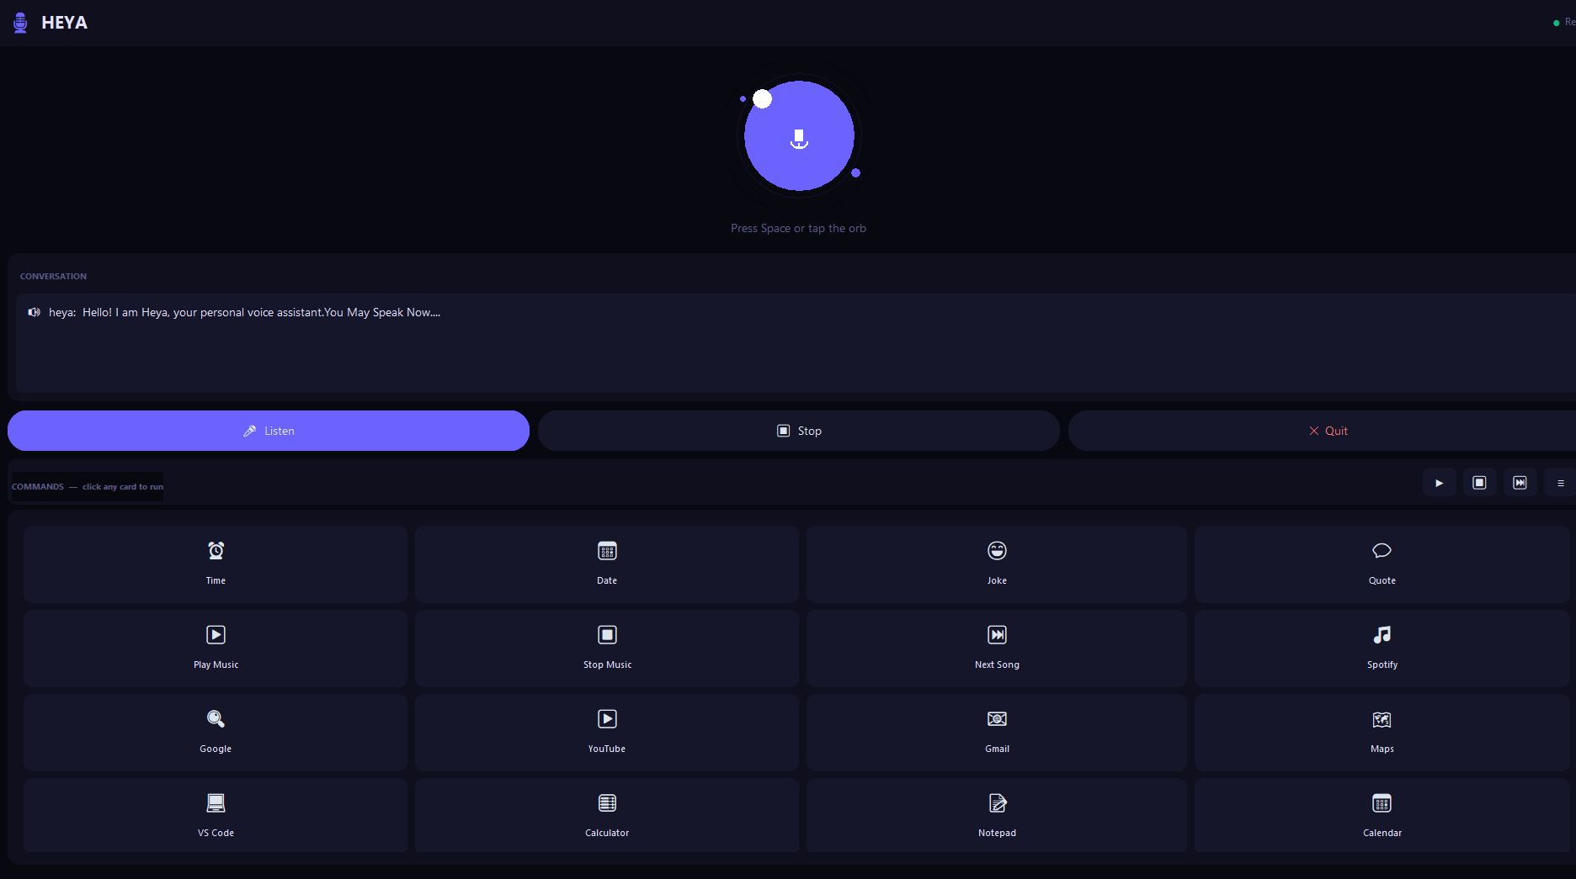
Fig-7.1 Interface showing the Start and Stop controls of the assistant

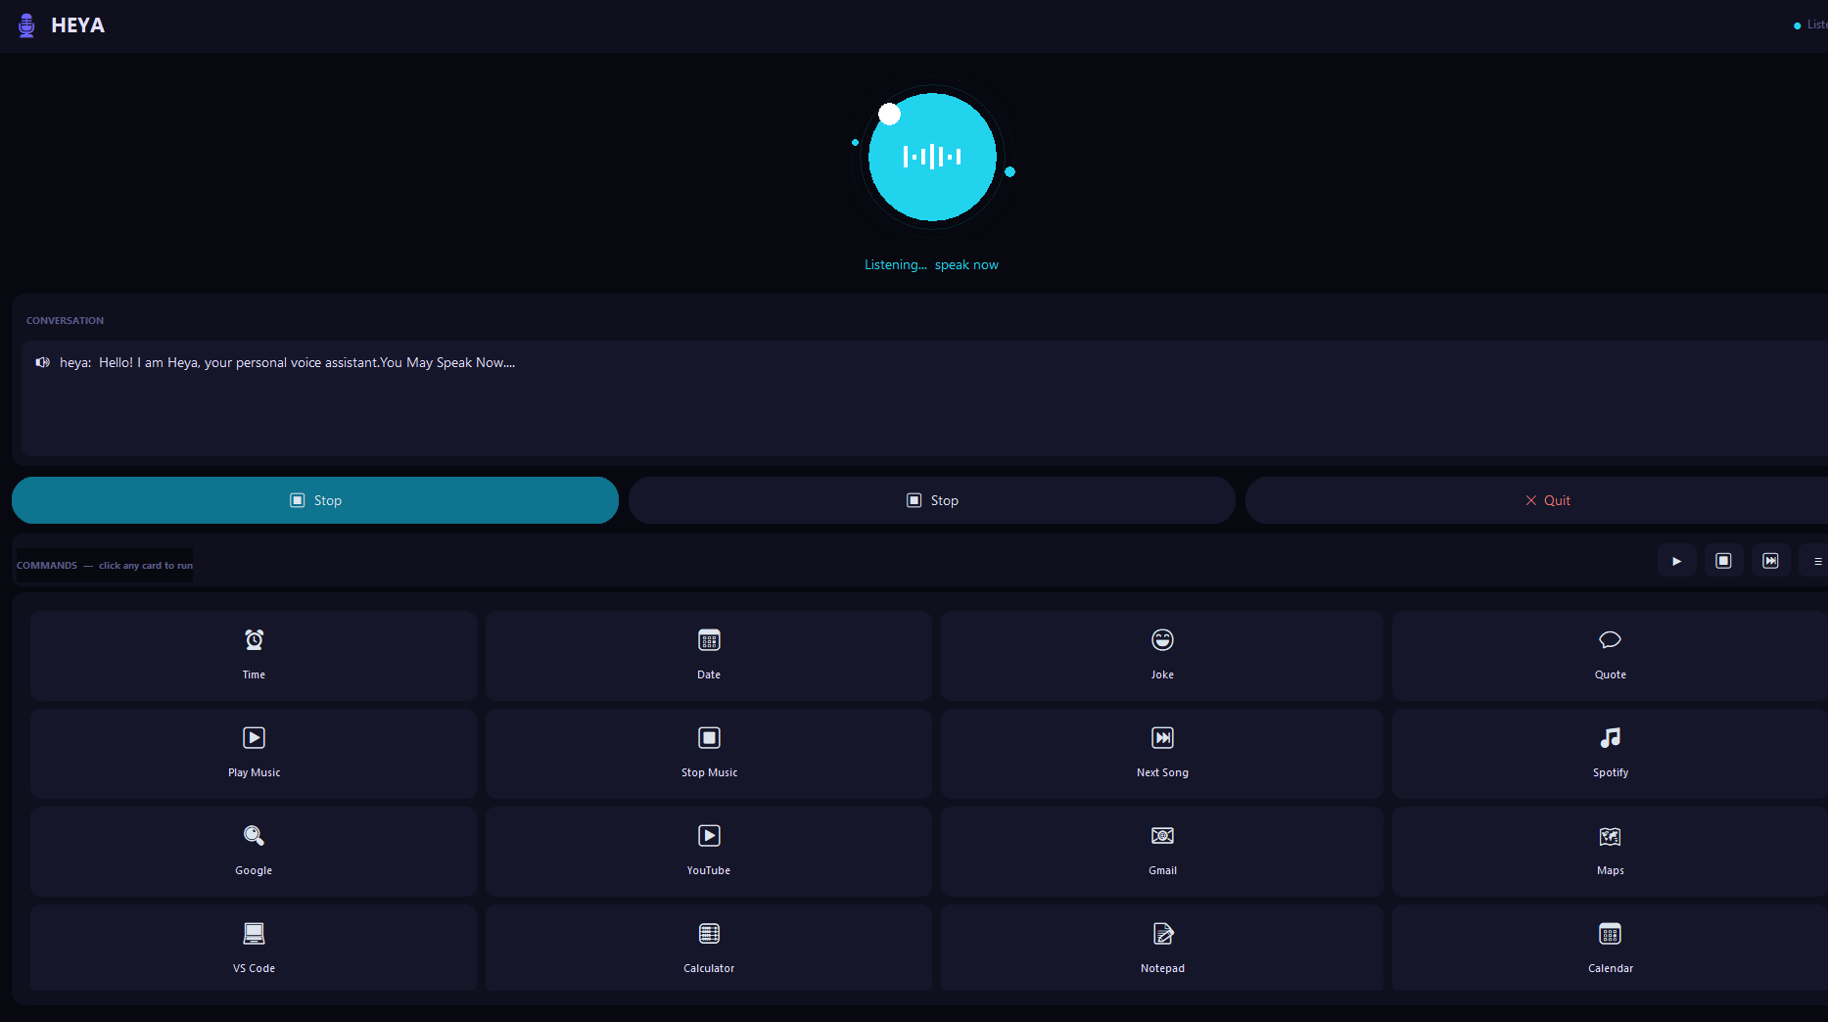

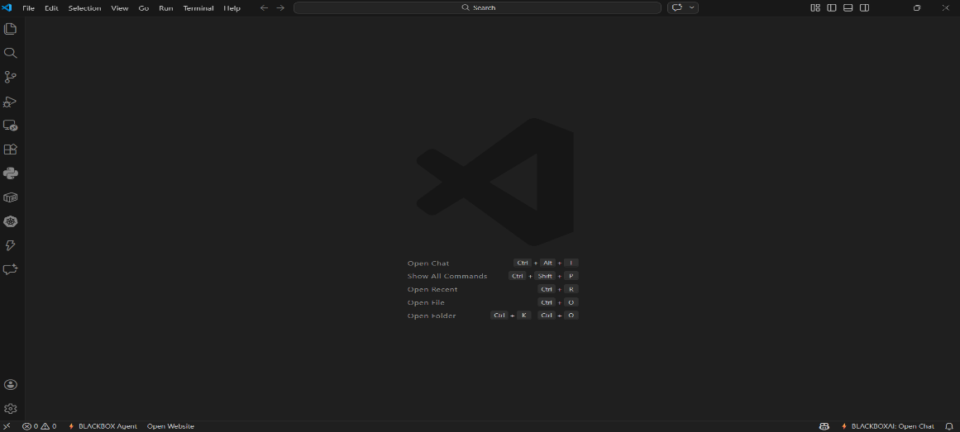
Fig-7.2 When the user starts speaking, the interface appears as shown. When the user says ‘Open VS Code,’ the system recognizes the command and opens the Visual Studio Code application

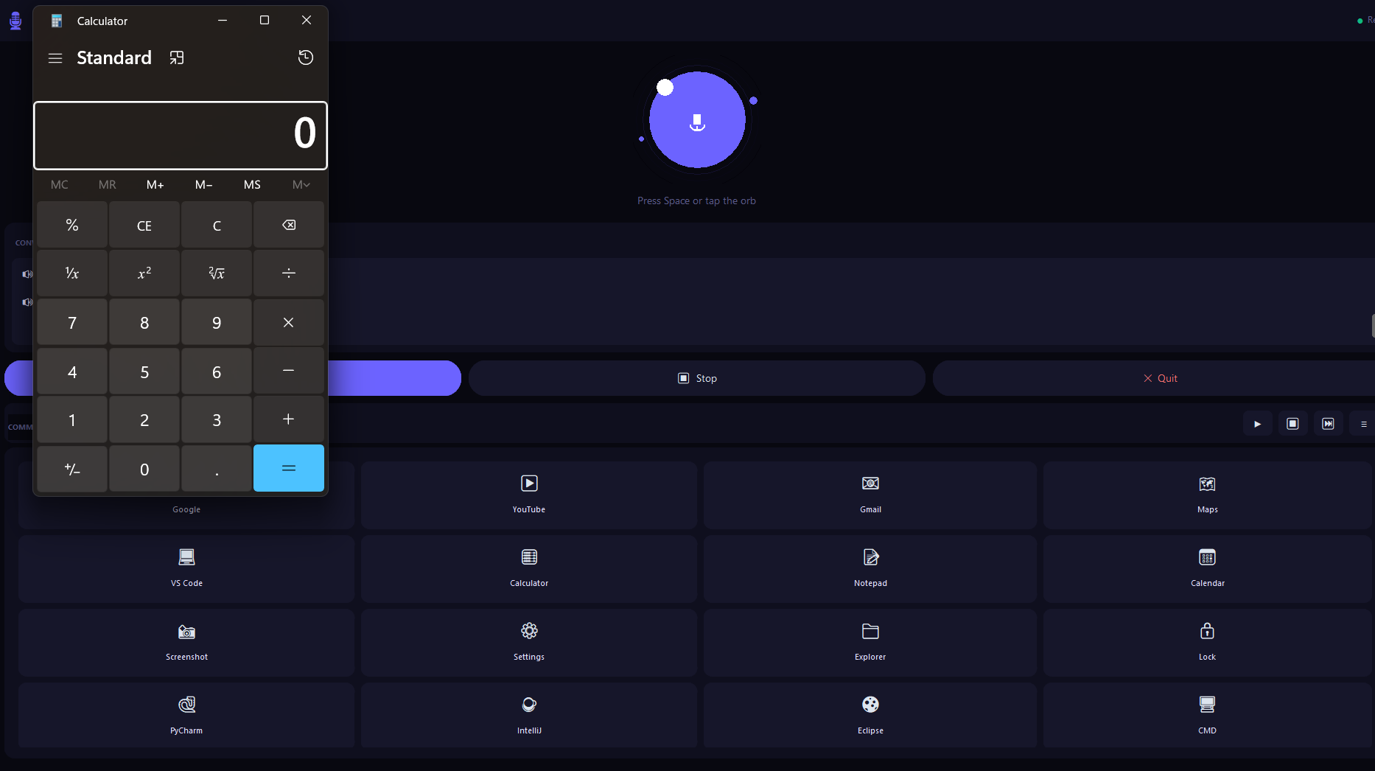
Fig. 7.3: When the user says ‘Open Calculator,’ the system recognizes the command and opens the calculator application.
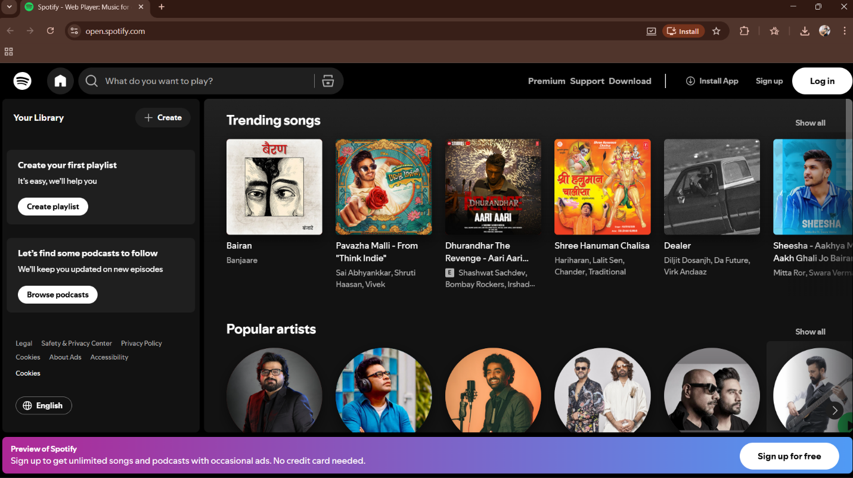
Fig. 7.4: When the user says ‘Open Spotify,’ the system recognizes the
command and opens the Spotify web page.

7.7 Backend summary

Backend Execution Flow:
- Receive audio input.
- Convert speech to text.
- Process command.
- Execute action.
- Generate response.
- Store command and response.
- Return output to frontend.

Backend Functional Results
1️. Speech Recognition
- Successfully converts speech into text.
- Handles normal speaking tone.
- Displays error when speech is unclear.
Result:
Accurate speech recognition under normal noise conditions.
2️.Command Processing
- Recognizes predefined commands.
- Converts input to lowercase.
- Matches keywords.
- Returns default response for unknown commands.
Result:
Command matching works effectively.
3️. Text-to-Speech Output
- Converts response text to speech.
- Plays voice output clearly.
- Works offline.
Result:
Voice output is generated successfully.

  - Summary

The execution and testing phase confirms that the Voice Based Virtual Assistant system operates successfully.
Achievements:
- Secure login system implemented.
- Real-time speech recognition achieved.
- Accurate command processing.
- Text-to-Speech integration successful.
- Command history stored and retrieved correctly.
- System runs smoothly in local environment.
Overall Result:
The Voice Based Virtual Assistant demonstrates:
- Efficient voice interaction.
- Reliable backend processing.
- Secure data management.
- User-friendly web interface.
- Stable and scalable architecture.
The system meets the objectives defined in the problem statement and successfully integrates speech technologies with web deployment.

CHAPTER 8
CONCLUSION
The Voice Based Virtual Assistant System was successfully designed, developed, and implemented using modern software technologies such as:
- Python
- Flask
- Speech Recognition
- Text-to-Speech (TTS)
- SQLite Database
The primary objective of this project was to create a customizable, secure, and efficient voice-controlled system that enables users to interact with computers through speech commands.
The system successfully achieved the following:
✔ Real-Time Speech Recognition
The assistant captures voice input through a microphone and converts it into text accurately under normal environmental conditions.
✔ Intelligent Command Processing
Recognized text is processed and matched with predefined commands, allowing the system to execute appropriate actions.
✔ Text-to-Speech Response
The assistant provides audible responses using offline TTS technology, improving user interaction.
✔ Secure User Authentication
The system includes a login and registration mechanism with password hashing for secure access.
✔ Database Integration
All user interactions and command history are securely stored and retrieved using SQLite.
✔ Web-Based Interface
A user-friendly dashboard built with Flask and Bootstrap enables easy interaction and monitoring.

CHAPTER 9
FURTHER ENHANCEMENTS

Further Enhancements
Although the current system performs efficiently, several improvements can enhance its functionality, scalability, and intelligence.
1️. Natural Language Processing (NLP) Integration
Currently, the system uses keyword-based command matching. Future upgrades may include:
- Advanced NLP models
- Intent classification
- Context understanding
- Sentiment analysis
This will improve accuracy and conversational ability.
2️. Deep Learning-Based Command Recognition
Integrating advanced deep learning models such as:
- Recurrent Neural Networks (RNN)
- LSTM Models
- Transformer-based models
can significantly enhance speech understanding and contextual awareness.
3️. Multi-Language Support
Future versions can support:
- Multiple regional languages
- Accent adaptation
- Automatic language detection
This will make the system more inclusive and globally usable
4️. Cloud Deployment
The system can be deployed on cloud platforms to:
- Improve scalability
- Enable remote access
- Provide real-time API integrations
Cloud hosting can make the assistant accessible from anywhere.

5️. Mobile Application Integration
Developing:
- Android application
- iOS application
will allow mobile users to interact with the assistant conveniently.
6️. IoT Integration
The assistant can be connected to:
- Smart home devices
- Security systems
- IoT appliances
This will allow voice-based automation of smart environments.
7️. AI-Based Personalization
Future improvements can include:
- Learning user preferences
- Personalized responses
- Adaptive speech tone
- Custom voice profiles
8️. Enhanced Security Features
Additional security measures may include:
- Two-factor authentication
- Voice-based biometric authentication
- Encrypted database storage
- Secure API communication
9️. Continuous Listening with Wake Word Detection
Adding wake-word detection such as:
- “Hey Assistant”
- “Computer”
will allow continuous background listening without manual button clicks.

CHAPTER 10
REFERENCES
    - Hirschberg and Manning [1] reviewed major advances in natural language processing, including statistical and deep learning approaches. Their work highlighted how NLP improvements directly contribute to better speech understanding and dialogue systems.
    - Hashimoto et al. [9] analyzed machine translation and speech synthesis in speech-to-speech translation systems. Their findings showed that integrating translation with speech synthesis improves communication across languages, expanding the scope of voice assistants.
    - Mittal and Toshniwal [10] developed a voice-controlled smart home automation system. Their research demonstrated how voice assistants can effectively control household appliances, enhancing convenience and accessibility.
    - Wadikar et al. [11] implemented a home automation system using Hindi voice commands, highlighting the importance of multilingual support in voice-based systems, especially in non-English-speaking regions.
    - Peng and Chen [12] designed a smart socket control system using Google Home and Raspberry Pi. Their work showcased the integration of voice recognition with IoT devices.
    - Singh and Kabra [13] proposed an on-device speech detection system to improve human–computer interaction. Their approach reduced dependency on cloud services and improved privacy and response time.
    - Jung et al. [14] presented a deep learning framework for speaker verification in noisy environments. Their research addressed real-world challenges such as background noise and short speech duration.
    - Chiu et al. [15] developed an emotionally aware virtual assistant for smart campuses. Their system analyzed user emotions to provide adaptive responses, demonstrating the role of affective computing in intelligent environments.
    - Iyer et al. [16] proposed a virtual assistant tailored for visually impaired users, focusing on voice-driven navigation and task execution.
    - Dhanraj [17] designed a desktop voice assistant capable of performing system-level tasks. The study emphasized the practicality of voice assistants for everyday computing.

